Name

Mathematics Stage 5 core
Graphing Lines

Book 2 | Recognise and graph equations  Examine parallel, horizontal and vertical lines | Version: 260720  Feedback:  https://MrDingMaths.com
Contents
Syllabus Content 2
Sketching Lines using a Table 3
Horizontal and Vertical Lines 10
Intercepts of a Line 16
Checking if a Point Lies on a Line 18

Syllabus Content
MA4-LIN-C-01 determines the midpoint, gradient and length of an interval, and graphs linear relationships, with and without digital tools
Recognise and graph equations
- Recognise that equations of the form $y=mx+c$ represent linear relationships or straight lines
- Construct tables of values and use coordinates to graph a variety of linear relationships on the Cartesian plane, with and without digital tools
- Identify the $x$- and $y$- intercepts of lines
- Determine whether a point lies on a line using substitution
Examine parallel, horizontal and vertical lines
- Explain that parallel lines have equal gradients/slopes
- Explain why the $x$-axis has the equation $y=0$ and the $y$-axis has the equation $x=0$
- Recognise $y=c$ as a line parallel to the $x$-axis and $x=k$ as a line parallel to the $y$-axis
- Graph vertical and horizontal lines

Sketching Lines using a Table

- Review
- Substitute into equations
- Substitute $x=3$ into  $$2x+5$$ | - Substitute $x=3$ into  $$5-2x$$ | - Substitute $x=-3$ into  $$2x+5$$

- Complete a table of values
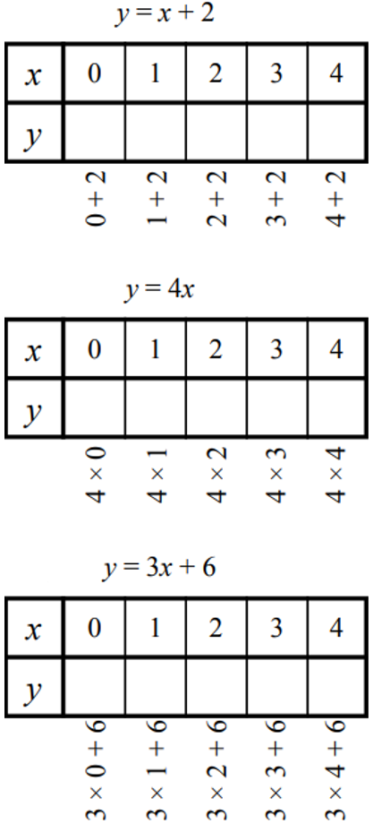 |  | 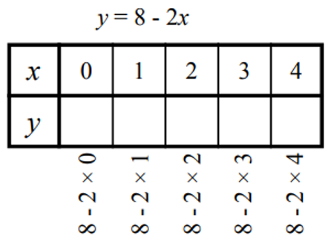

- Identify coordinates from a table of values
Plot this table of values on the Cartesian plane to the right.
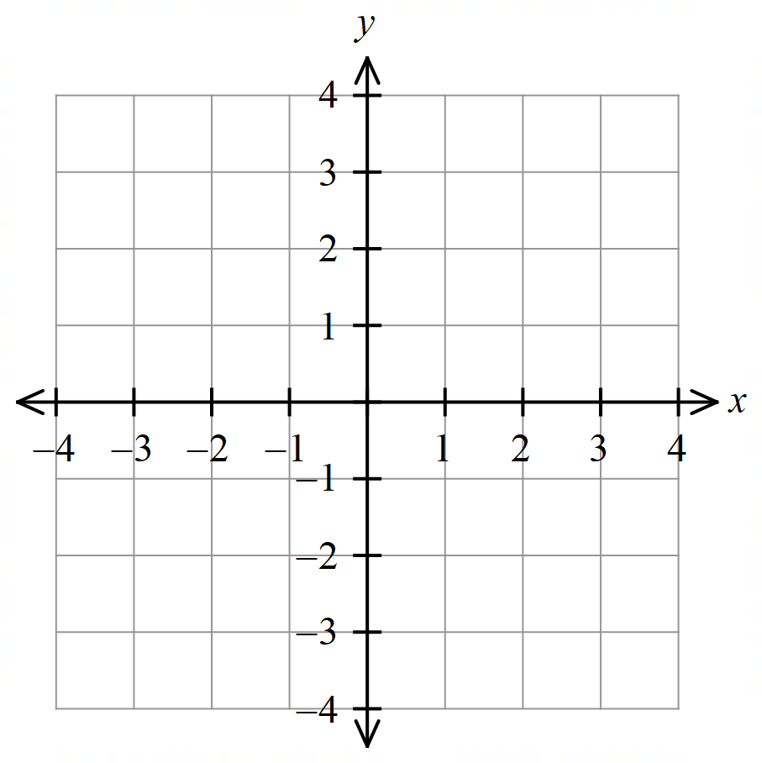

$$x$$ | $$-1$$ | 0 | 1
$$y$$ | $$-1$$ | 1 | 3

- Equation of a Linear Relationship
Every linear relationship is in the form:
$$y=mx+c$$

- Identify equation of a linear relationship
✖  $$y=x^{2}$$ | ✔  $$y=2x$$ |  | ✔  $$y=9-12x$$ |  | ✔  $$y=\frac{x}{6}-22$$ |  | ✖  $$y=\frac{6}{x}-22$$
Identify which of the following are linear relationships
$$y=5x+1$$ |  | $$y=1+5x$$ |  | $$y=x^{2}-7$$ |  | $$y=\frac{x}{2}-7$$
$$y=\frac{2}{x}$$ |  | $$y=3^{x}$$ |  | $$y=x$$ |  | $$y=9$$
$$y=3-7x$$ |  | $$y=-12x+6$$ |  | $$y=x^{3}-5$$ |  | $$y=80-\frac{5x}{3}$$

- Sketch a Line from a Table of Values
Some equations are called linear relationships because when we plot their $x$-$y$ pairs, it forms a straight line.

- Construct a table of values by substituting $x$ values into the equation to find $y$.
- Plot the $\left(x,y\right)$ points on a Cartesian plane.
- Draw a straight line through the points and extend it.

- Example Graph a linear relationship using a table of values
Draw the graph of the equation $y=2x+1$
$$x$$ | 0 | $$1$$ | 2 | 3
$$y$$ | 1 | 3 | 5 | 7
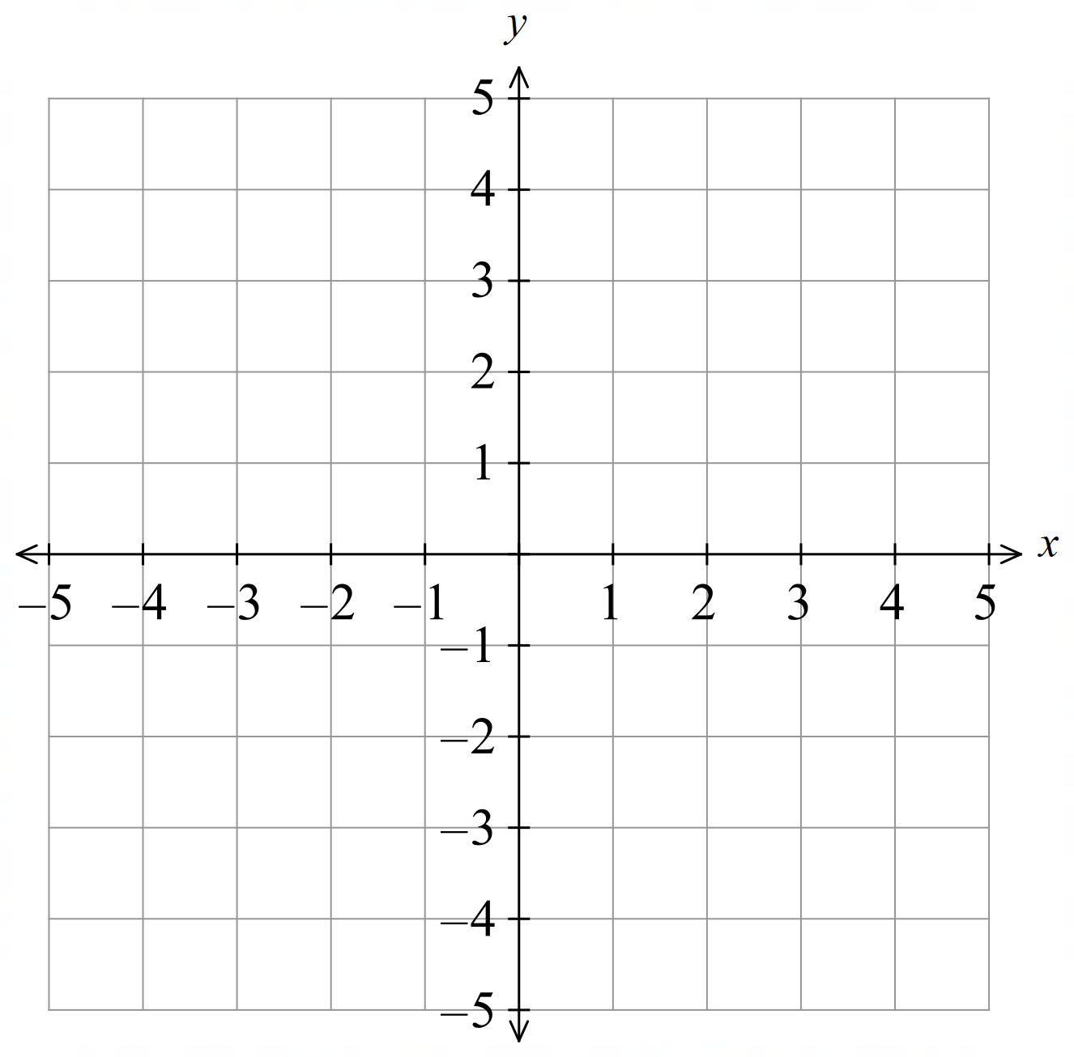

- Guided Practice
Draw the graph of:
- $y=2x-1$ | - $y=4-x$  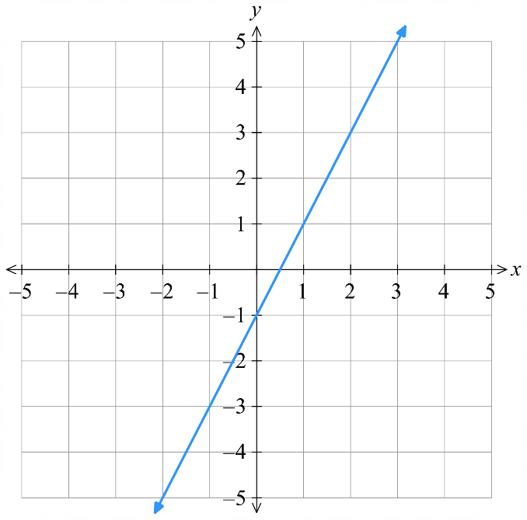  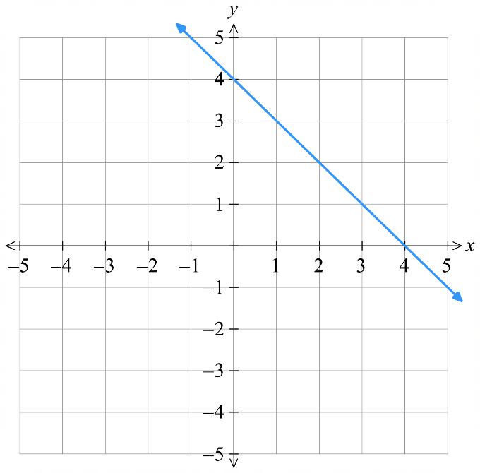
  $$x$$ | 0 | 1 | 2 | 3
  $$y$$
  $$x$$ | 0 | 1 | 2 | 3
  $$y$$

- Key Ideas
- Each column of a table of values can be written as a ……………………
- When an equation forms points that make a straight line, we call it a ……………… relationship.

Foundation
- Identify the coordinates from the table of values.
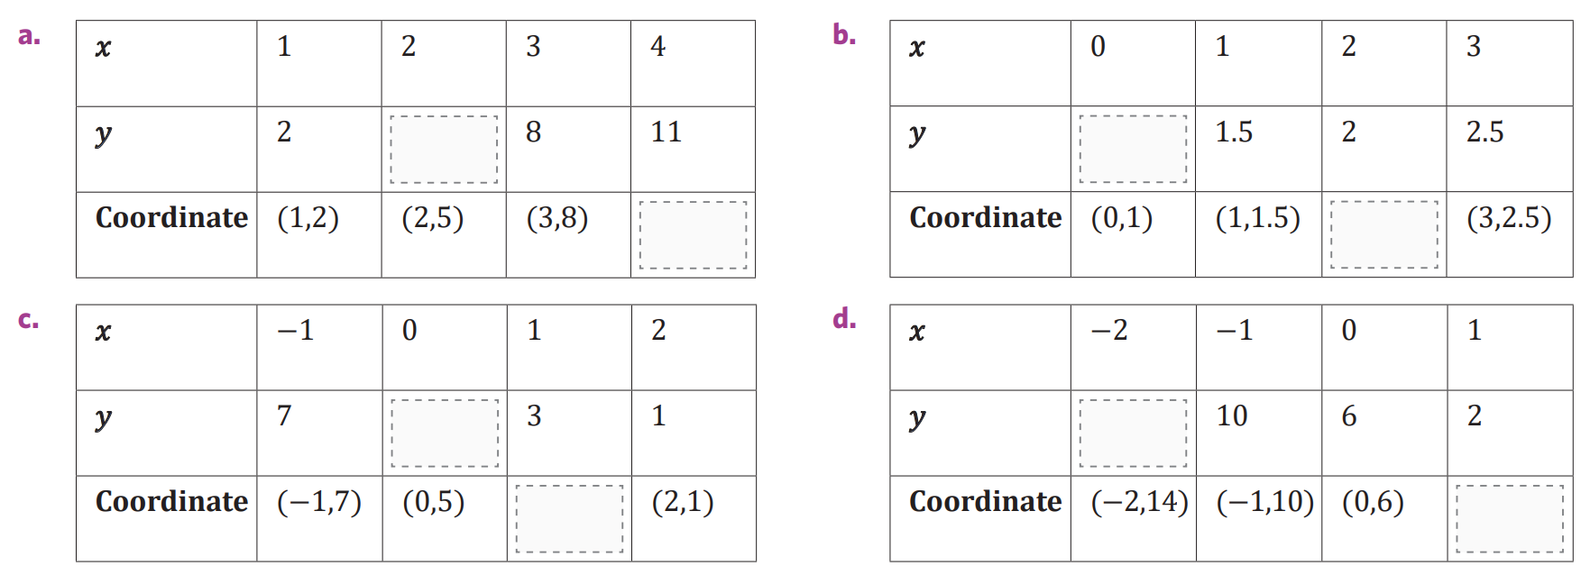  $$5$$  $$\left(4,11\right)$$ | $$1$$  $$\left(2,2\right)$$
$$5$$  $$\left(1,3\right)$$ | $$14$$  $$\left(1,2\right)$$

- Complete the table of values and graph the result.
- $y=x+1$  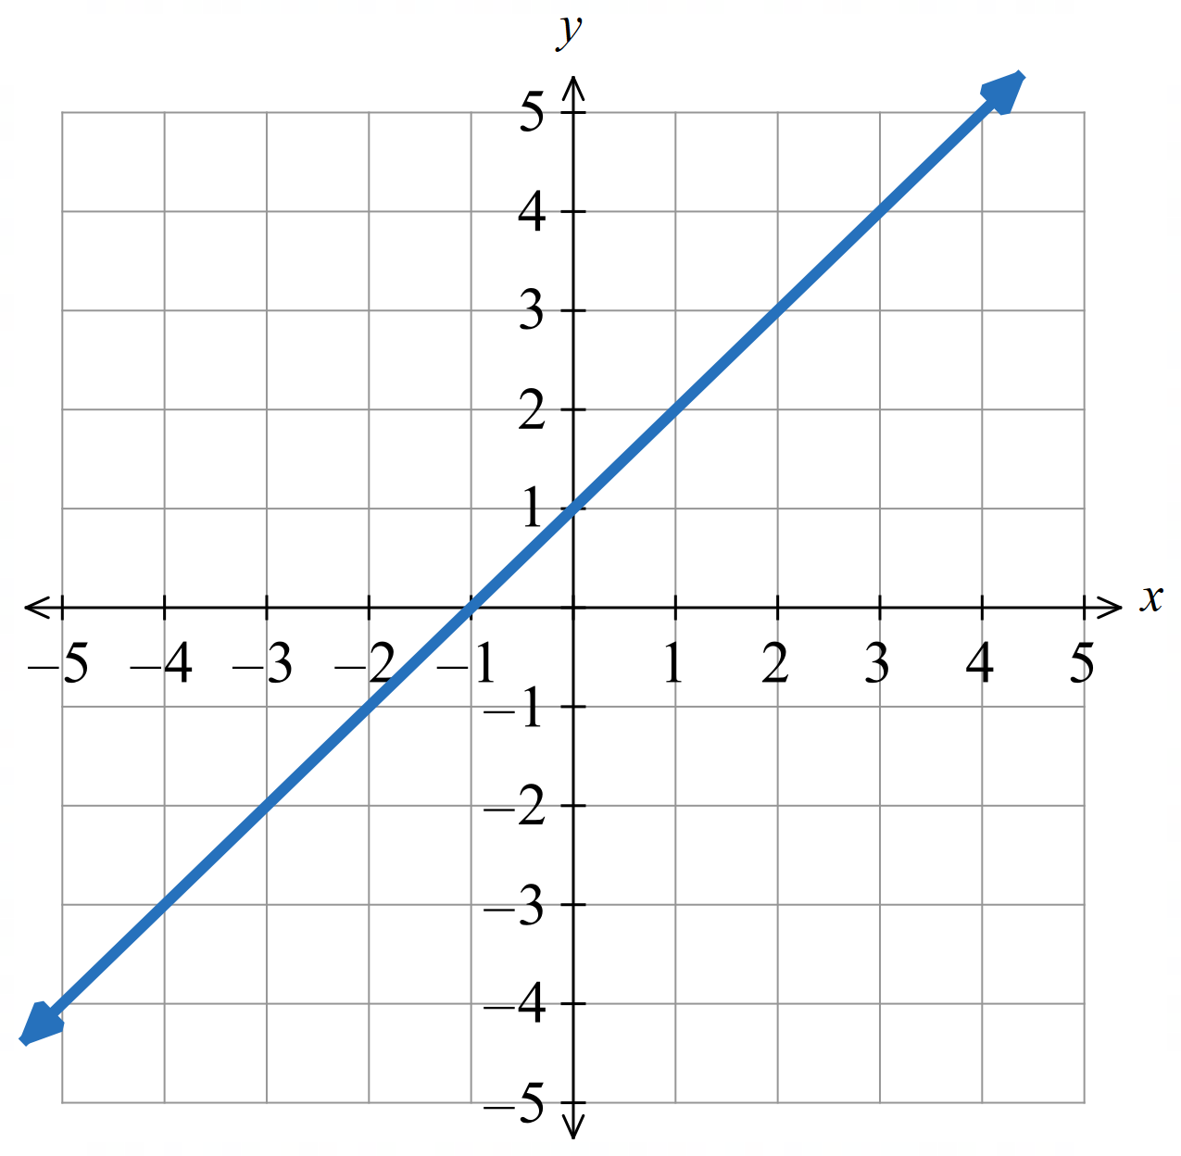 | - $y=2x+1$  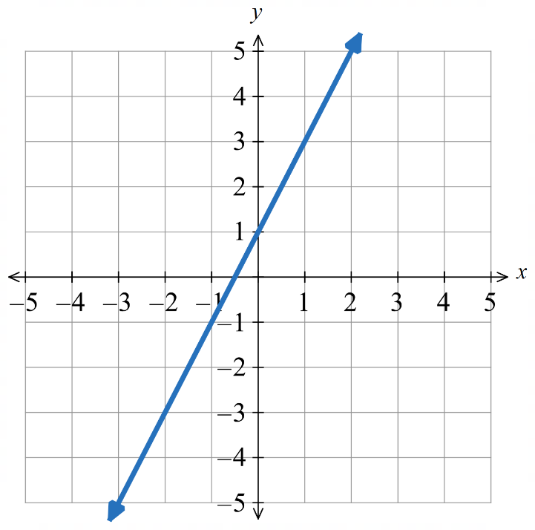  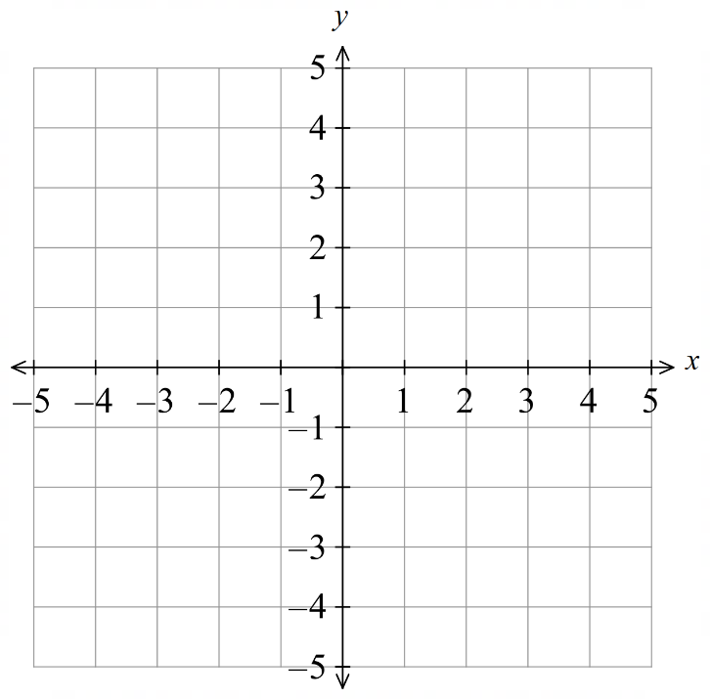
  $$x$$ | 0 | 1 | 2 | 3
  $$y$$
  $$x$$ | 0 | 1 | 2 | 3
  $$y$$
- $y=-x+1$  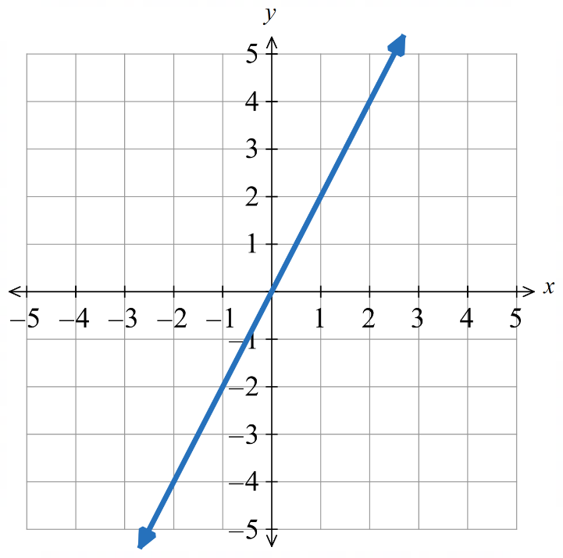  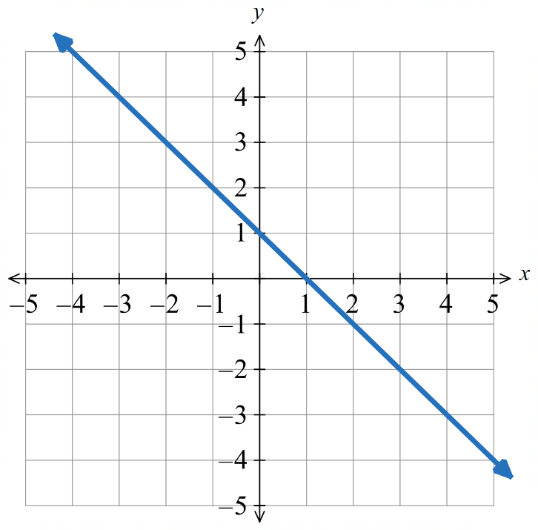 | - $y=2x$
  $$x$$ | 0 | 1 | 2 | 3
  $$y$$
  $$x$$ | 0 | 1 | 2 | 3
  $$y$$
- $y=x+3$  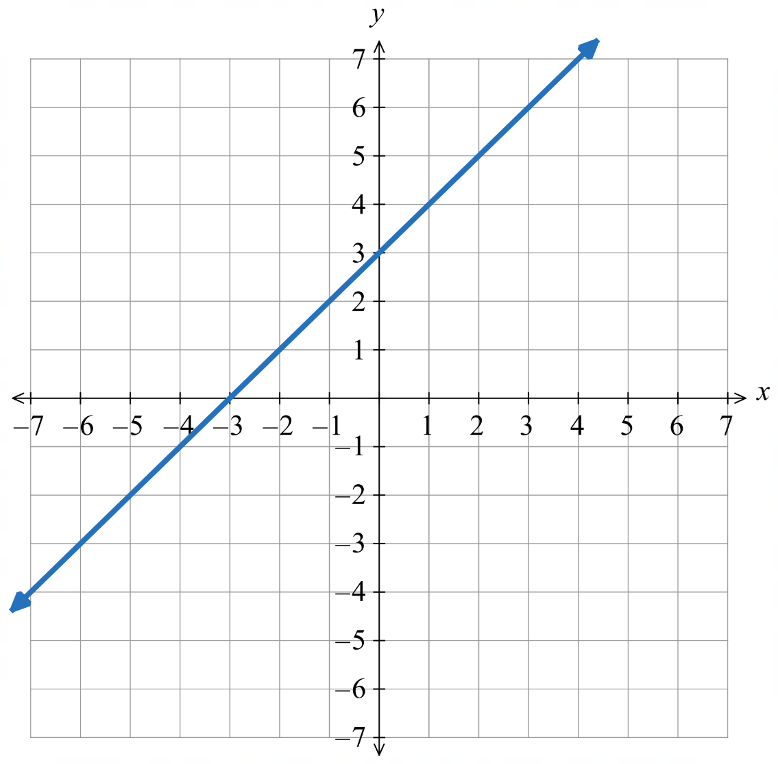  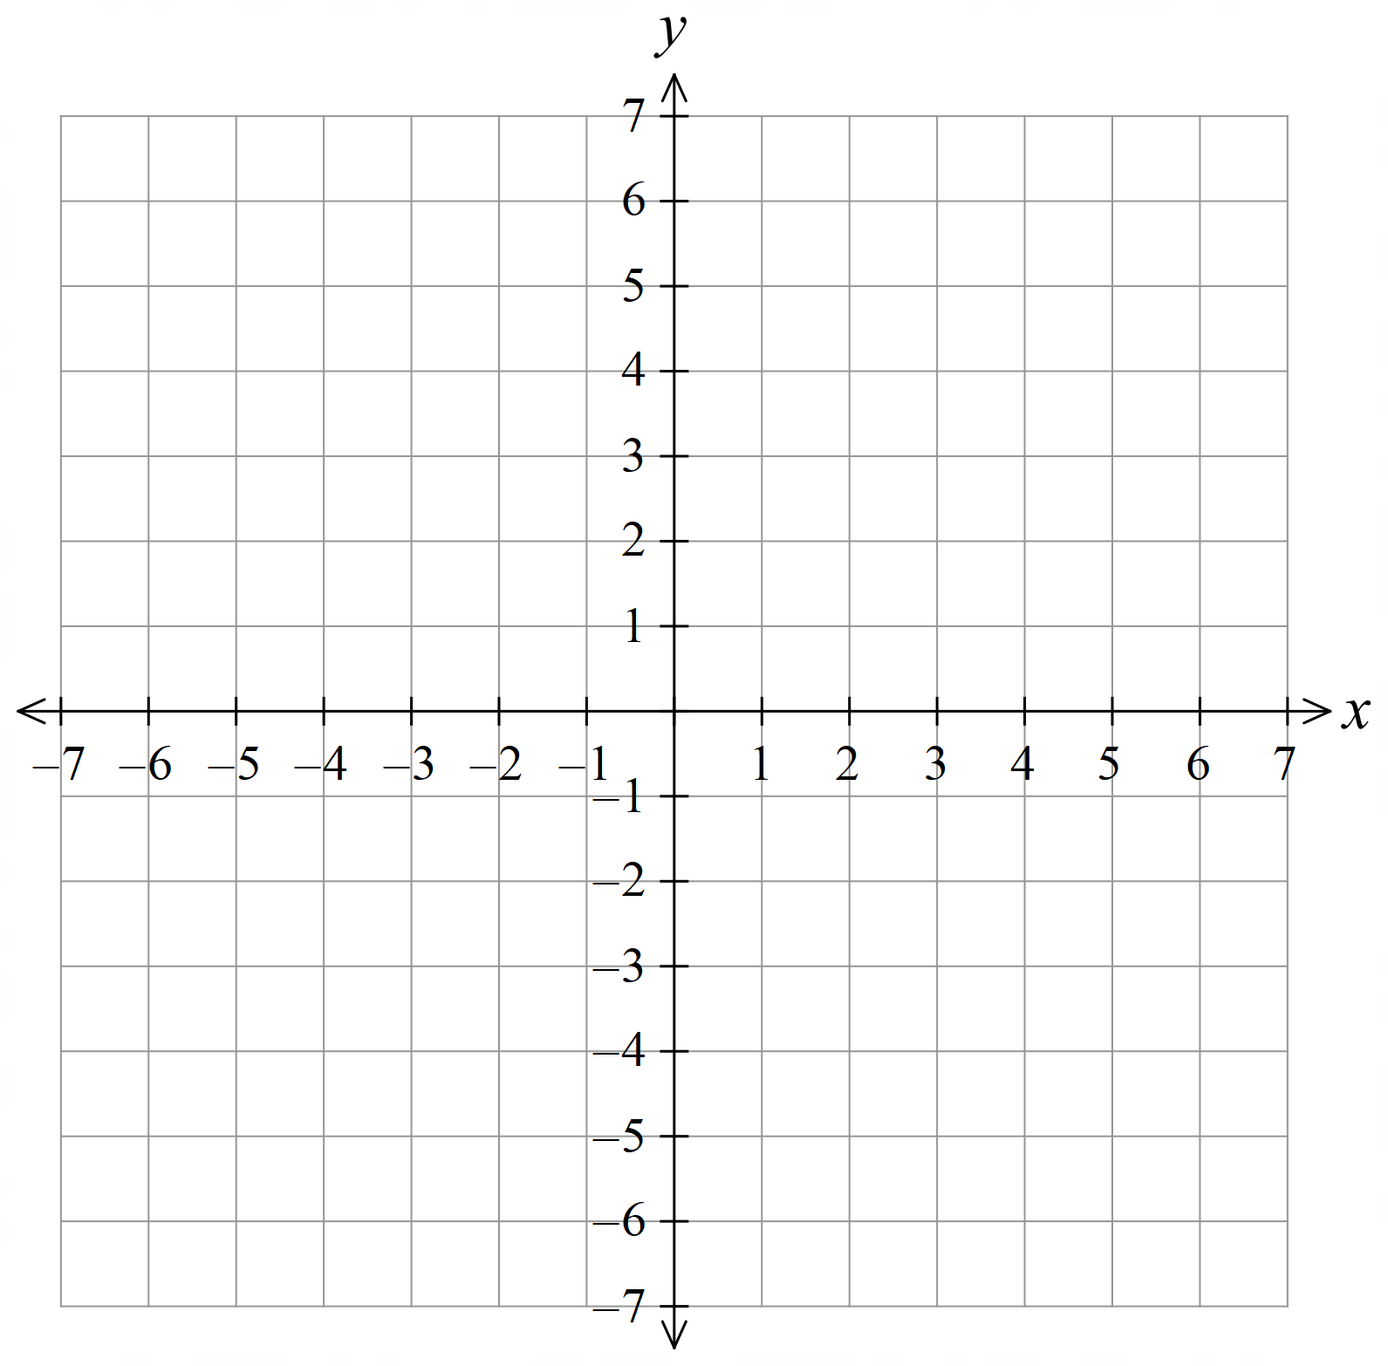 | - $y=3x-1$  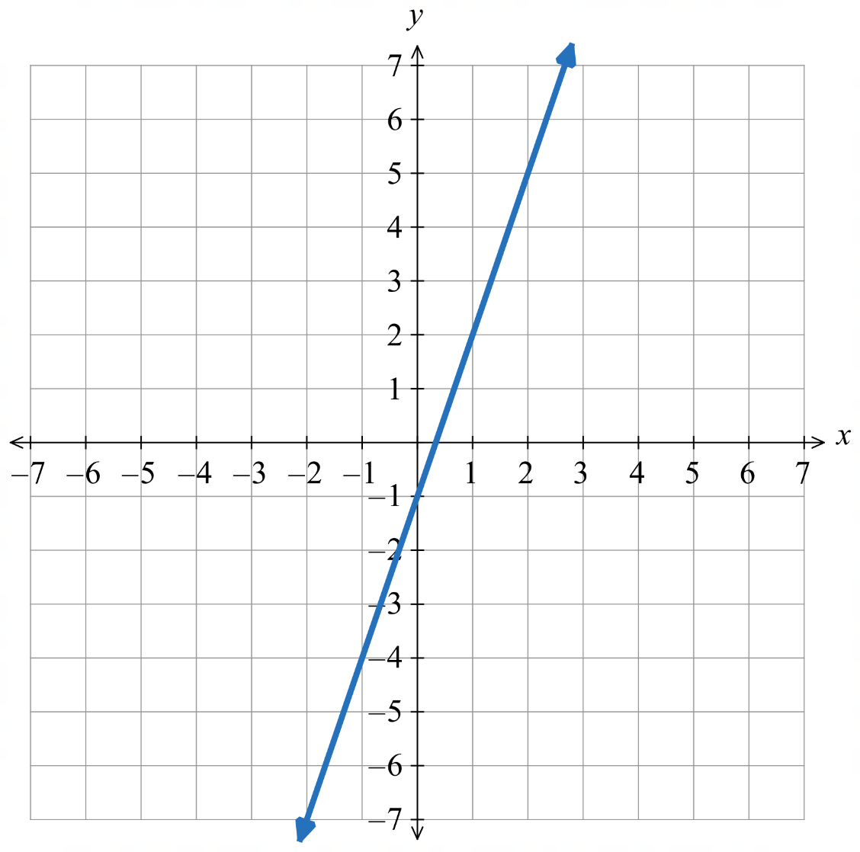
  $$x$$ | 0 | $$1$$ | $$2$$ | $$3$$
  $$y$$
  $$x$$ | 0 | $$1$$ | $$2$$ | $$3$$
  $$y$$
- $y=3x$  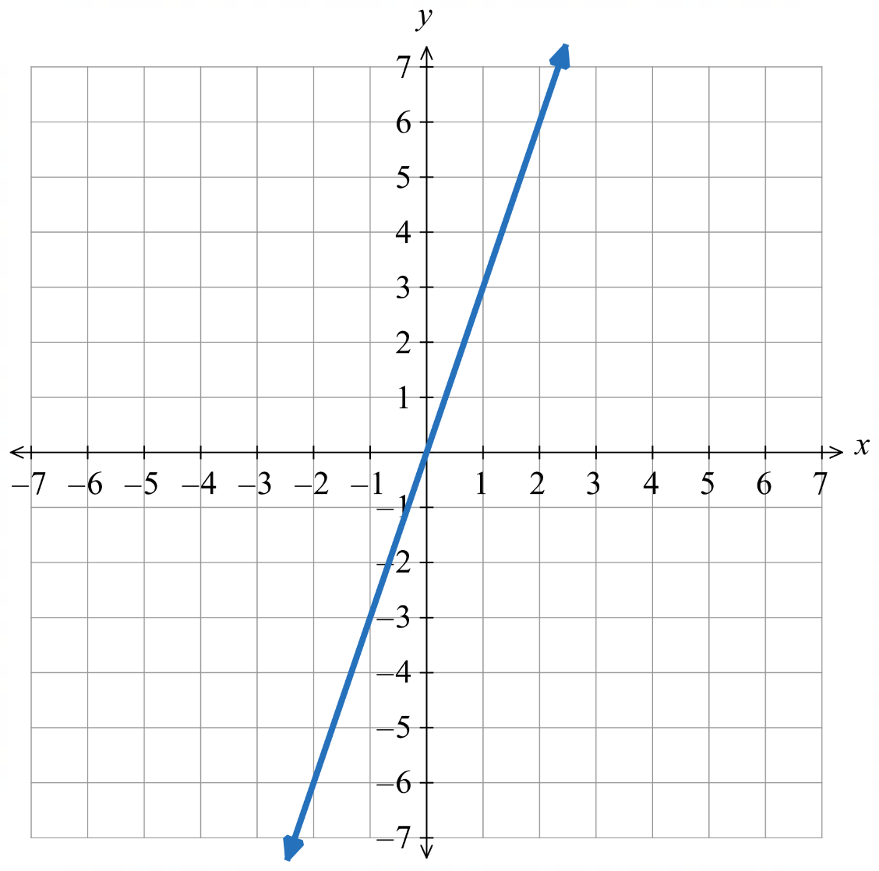 | - $y=-2x$  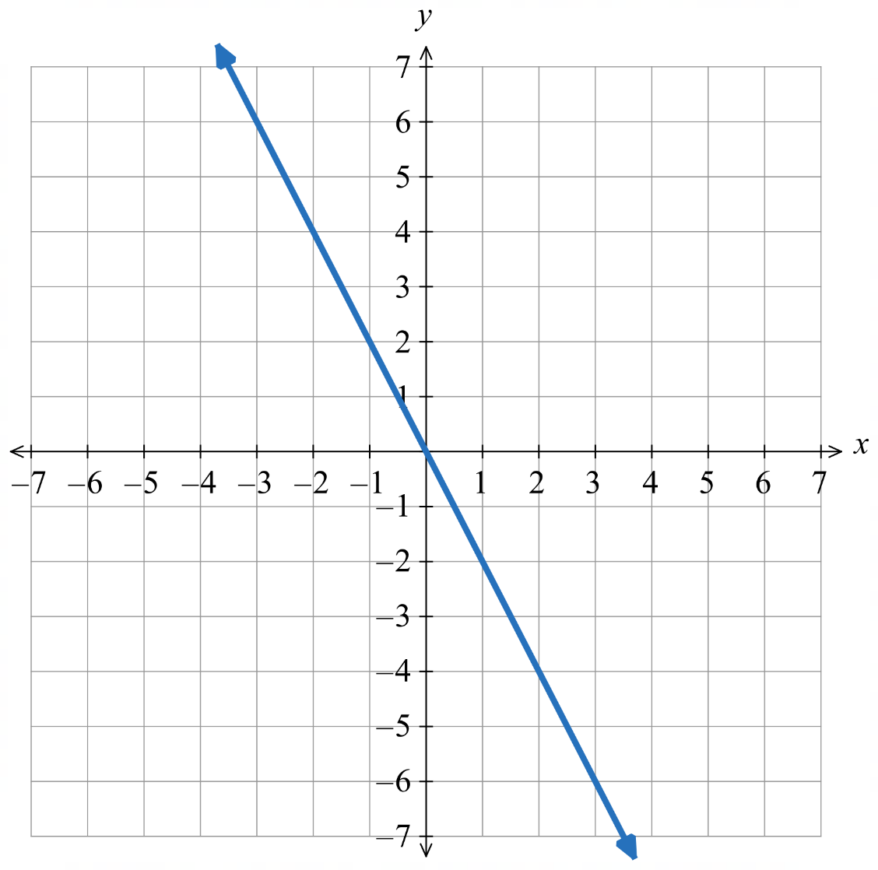
  $$x$$ | 0 | $$1$$ | $$2$$ | $$3$$
  $$y$$
  $$x$$ | 0 | $$1$$ | $$2$$ | $$3$$
  $$y$$

- $y=x+3$  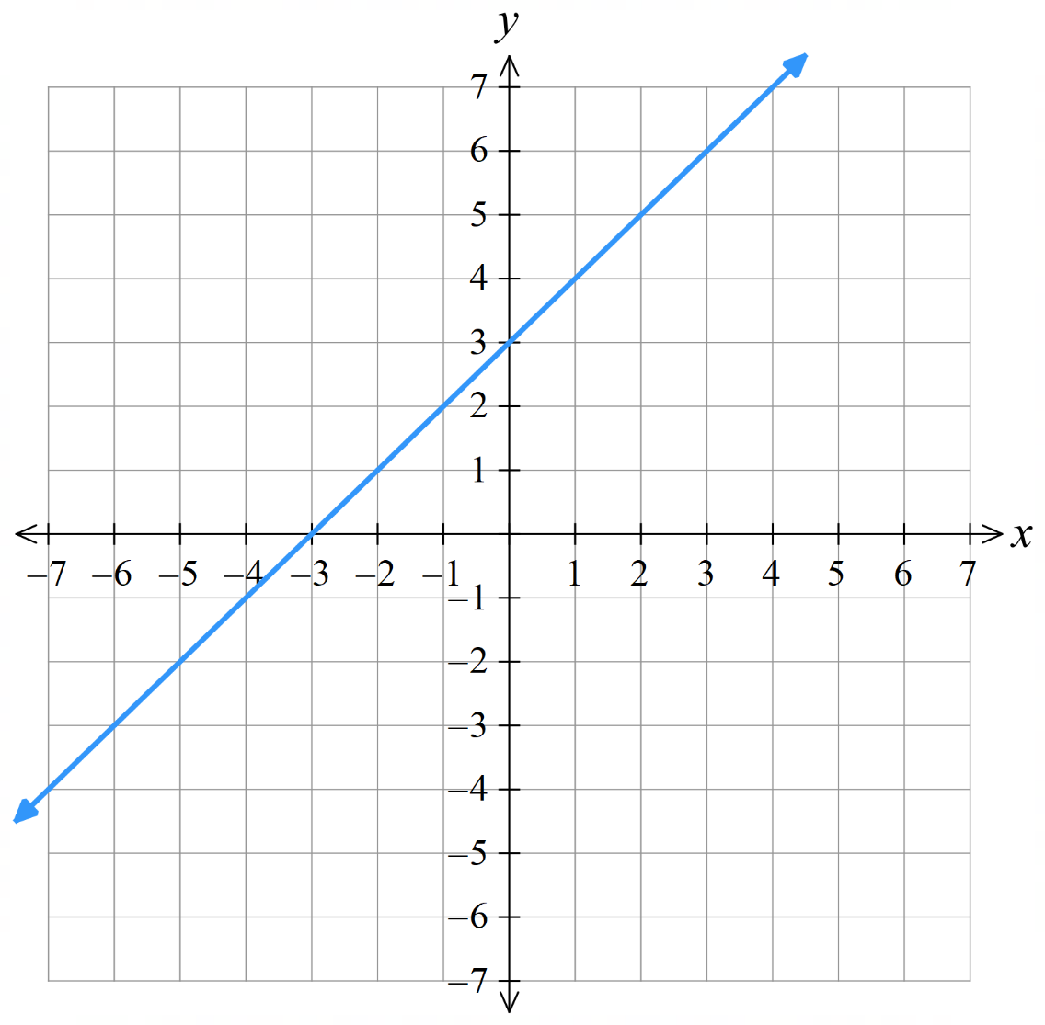 | - $y=x-1$  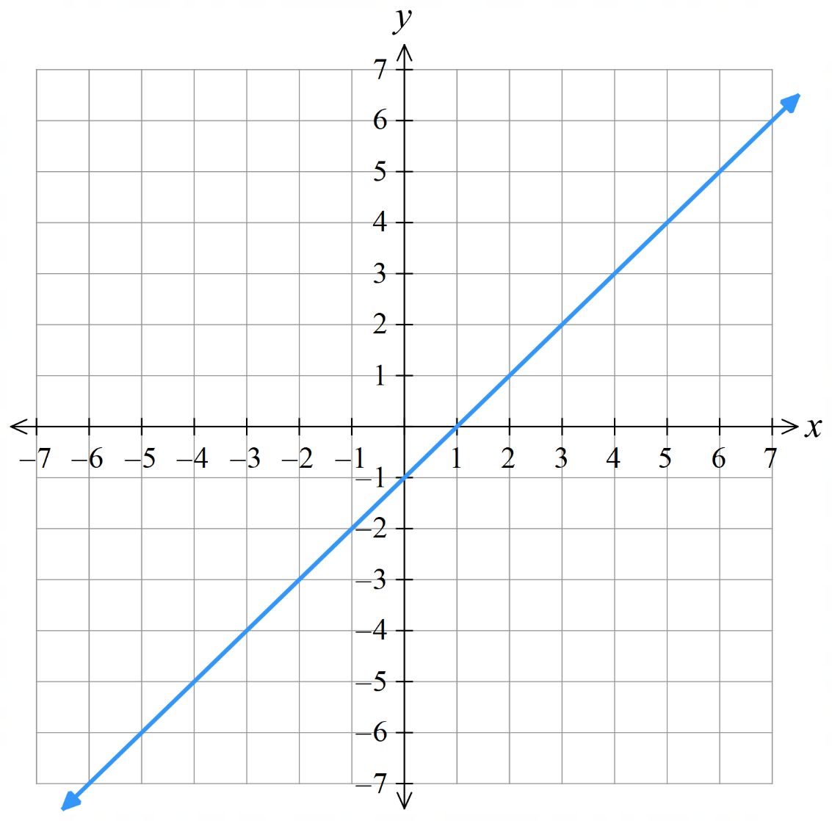
  $$x$$ | $$-2$$ | $$-1$$ | 0 | $$1$$ | $$2$$
  $$y$$
  $$x$$ | $$-2$$ | $$-1$$ | 0 | $$1$$ | $$2$$
  $$y$$
- $y=2x-3$  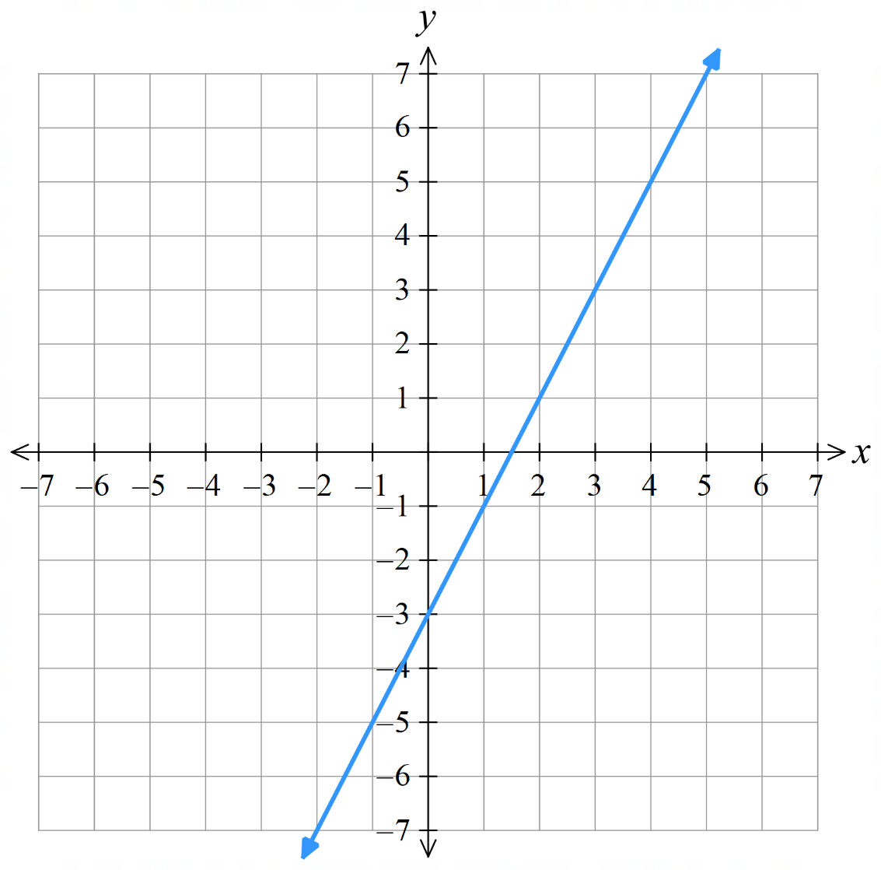 | - $y=-3x$  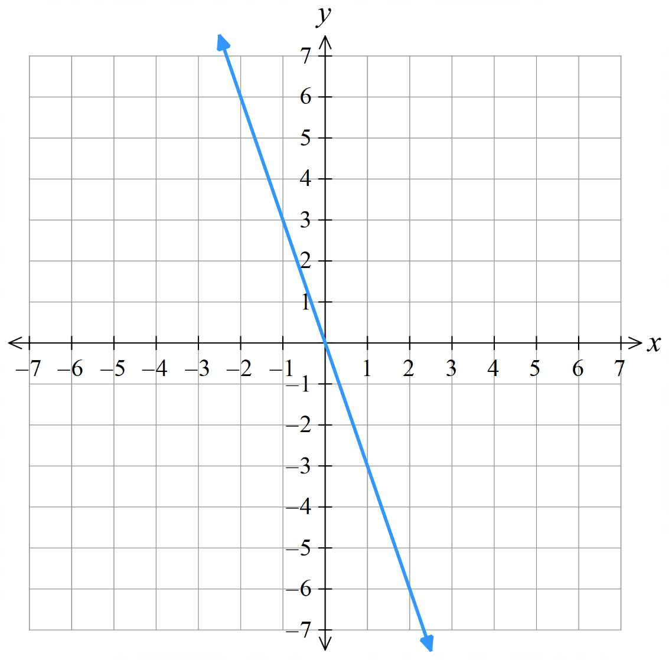
  $$x$$ | $$-2$$ | $$-1$$ | 0 | $$1$$ | $$2$$
  $$y$$
  $$x$$ | $$-2$$ | $$-1$$ | 0 | $$1$$ | $$2$$
  $$y$$

- $y=-2x-1$  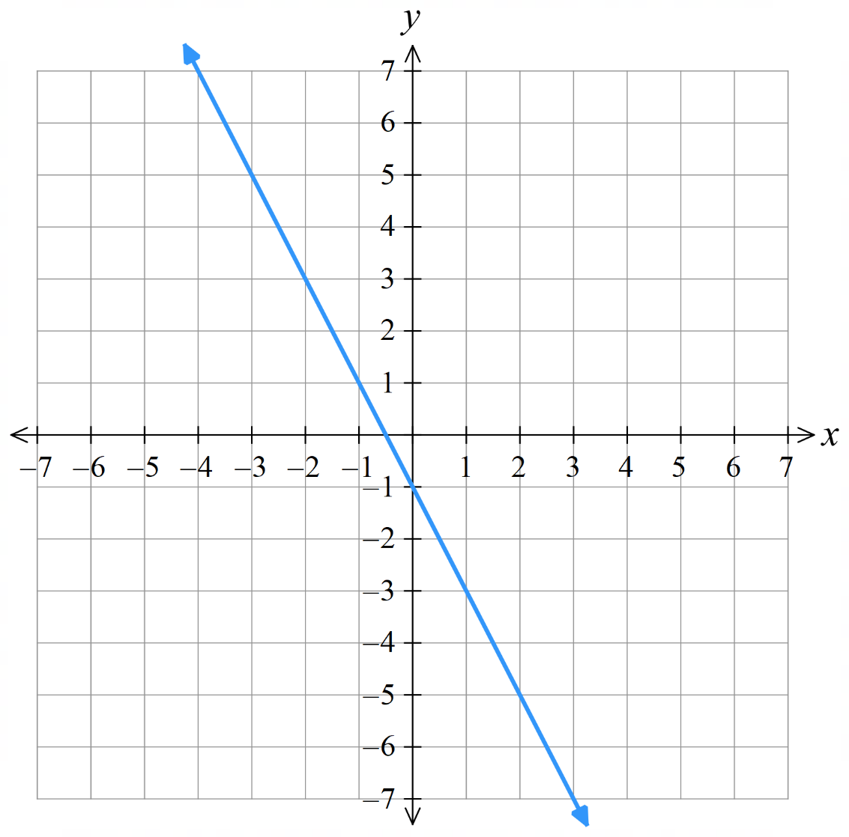 | - $y=-x+4$  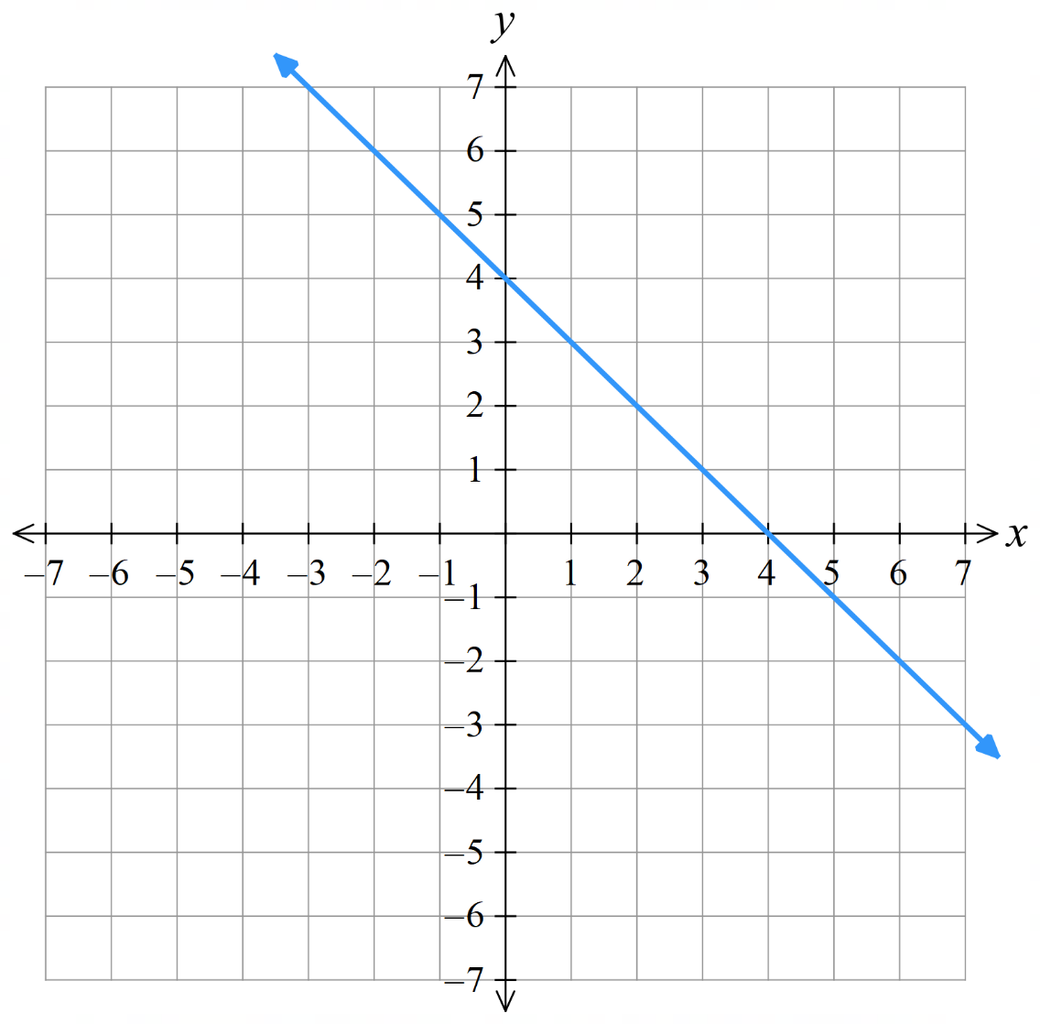
  $$x$$ | $$-2$$ | $$-1$$ | 0 | $$1$$ | $$2$$
  $$y$$
  $$x$$ | $$-2$$ | $$-1$$ | 0 | $$1$$ | $$2$$
  $$y$$
- $y=0.5x-3$  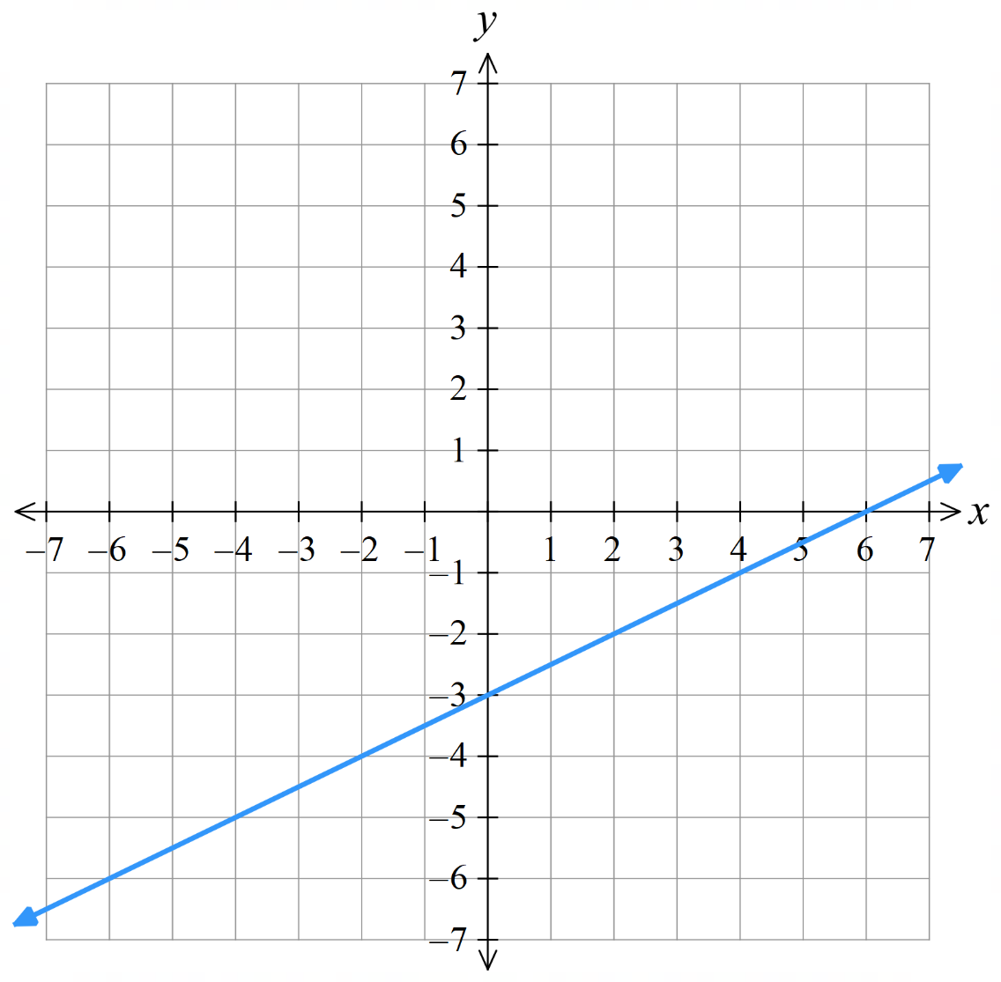 | - $y=1+2x$  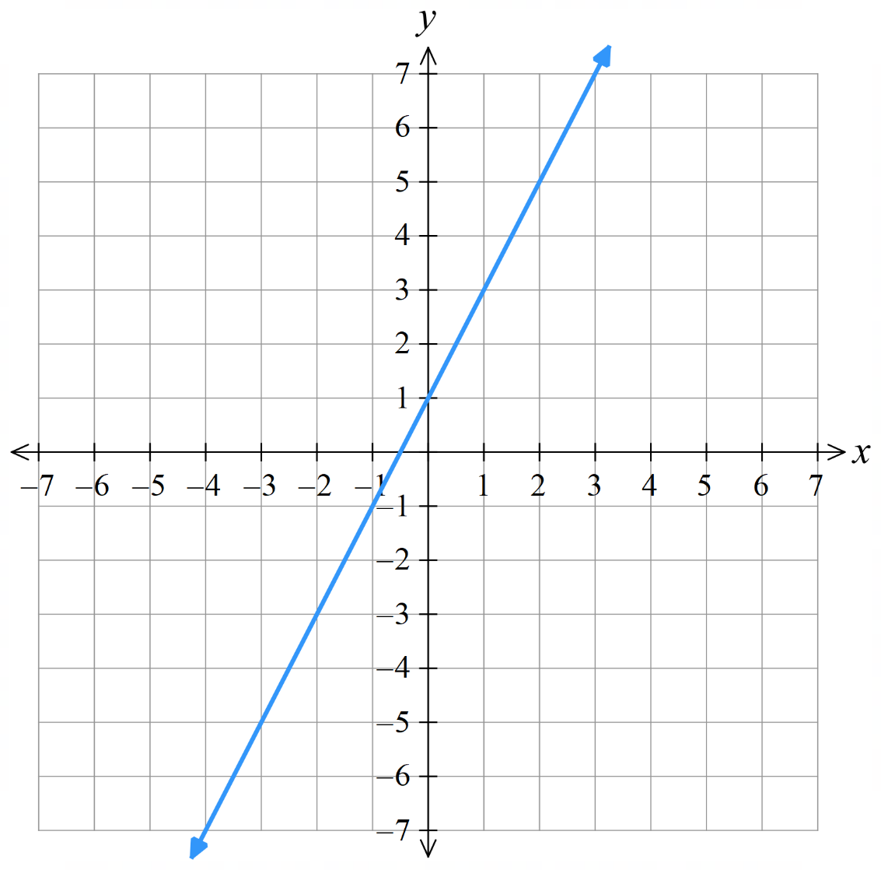
  $$x$$ | $$-2$$ | $$-1$$ | 0 | $$1$$ | $$2$$
  $$y$$
  $$x$$ | $$-2$$ | $$-1$$ | 0 | $$1$$ | $$2$$
  $$y$$

Development
- Complete the table of values and graph the result.
- $y=1.5-4x$  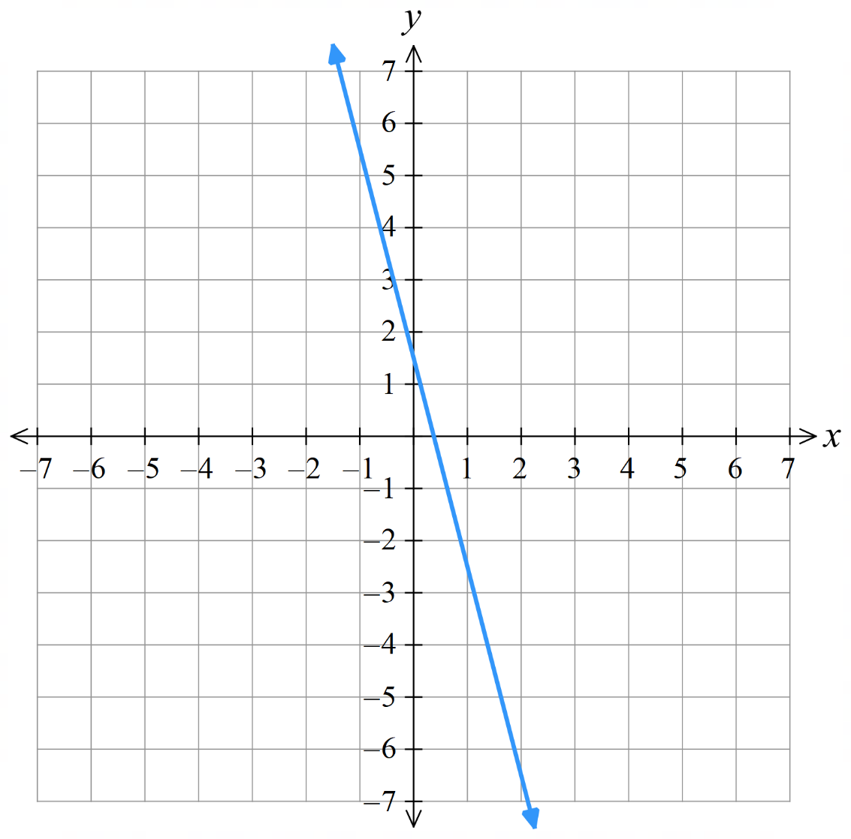 | - $y=3-x$  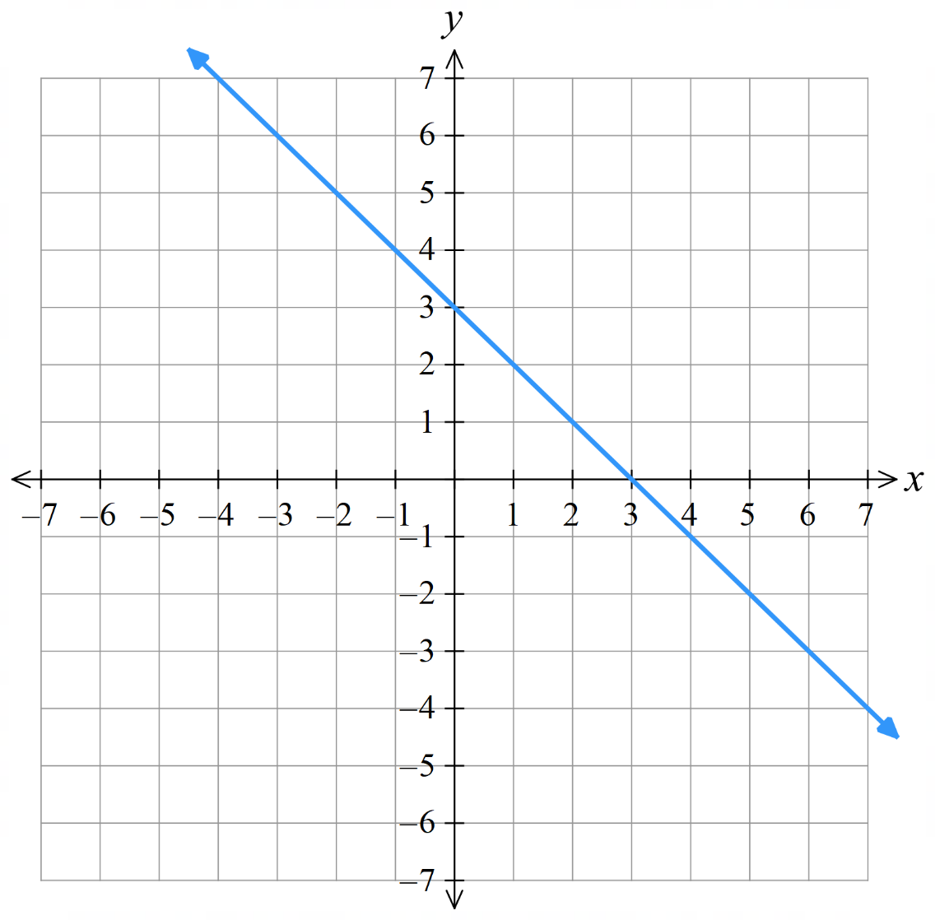
  $$x$$ | $$-2$$ | $$-1$$ | 0 | $$1$$ | $$2$$
  $$y$$
  $$x$$ | $$-2$$ | $$-1$$ | 0 | $$1$$ | $$2$$
  $$y$$
- $y=4-2x$  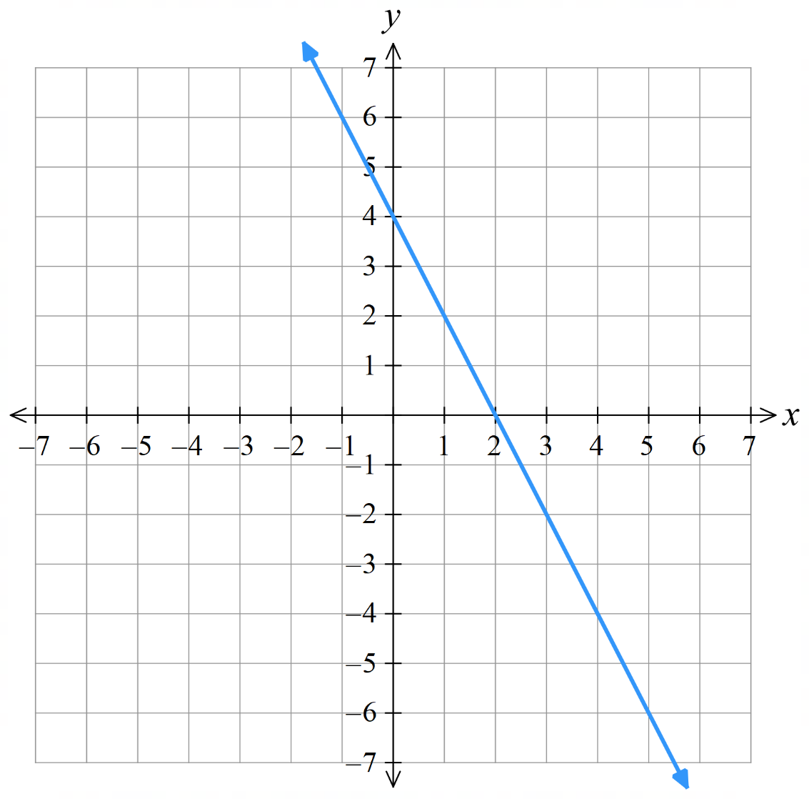 | - $y=1-\frac{5}{2}x$  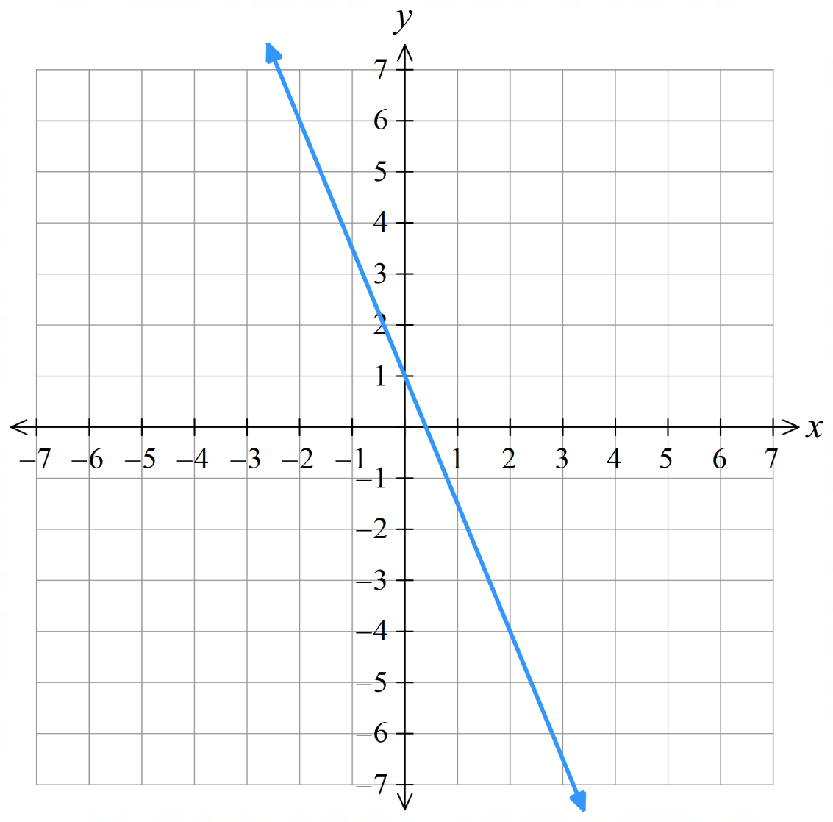
  $$x$$ | $$-2$$ | $$-1$$ | 0 | $$1$$ | $$2$$
  $$y$$
  $$x$$ | $$-2$$ | $$-1$$ | 0 | $$1$$ | $$2$$
  $$y$$

Mastery
- Match the rules A-D with the graphs a-d.
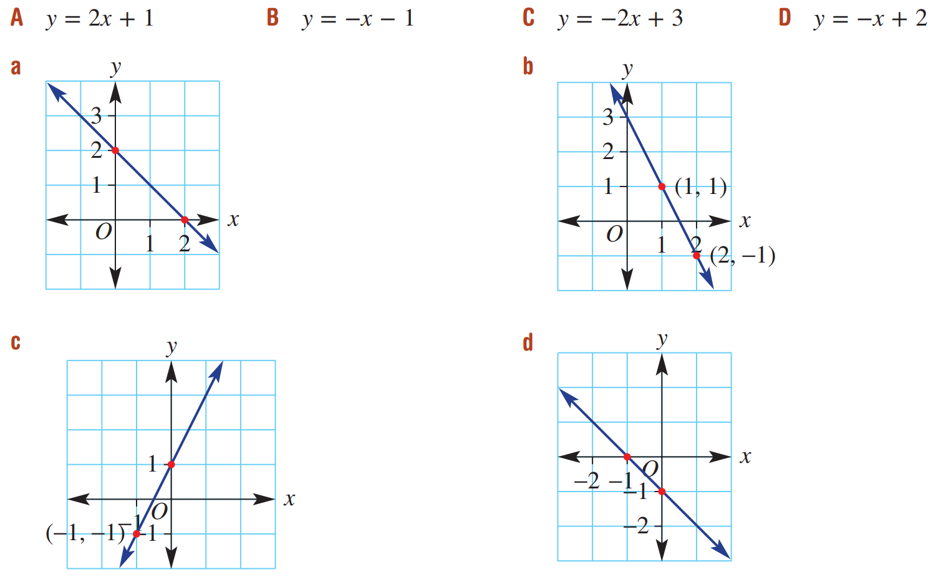

A – c, B – d, C – b, D – a

Horizontal and Vertical Lines

- Horizontal and Vertical Lines
$$y=c$$  Every $y$ coordinate is $c$.  Parallel to the $x$ axis  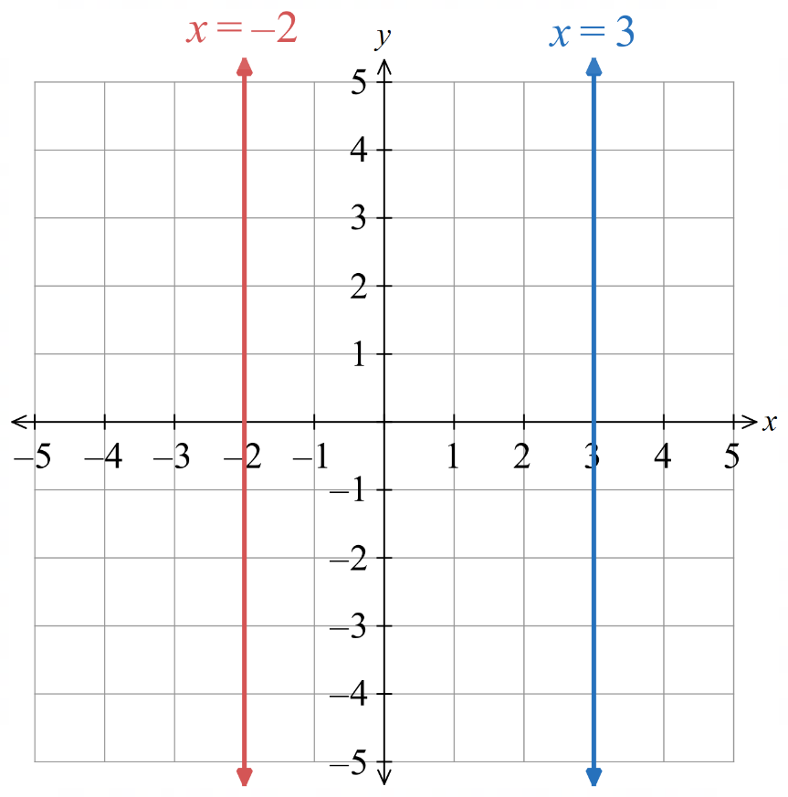  The $x$ axis has equation $y=0$  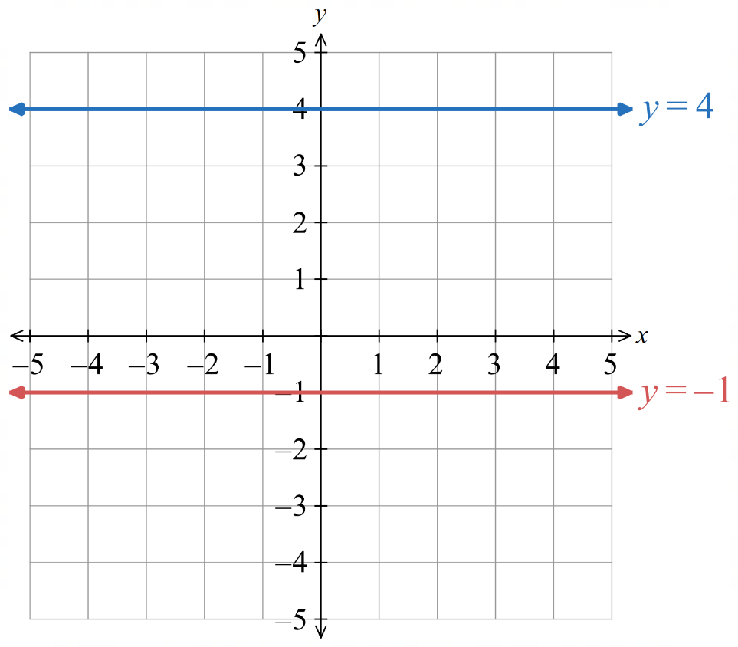  The gradient of a horizontal line is 0:  $$m=\frac{0}{run}=0$$ | $$x=k$$  Every $x$ coordinate is $k$.  Parallel to the $y$ axis  The $y$ axis has equation $x=0$  The gradient of a vertical line is undefined:  $$m=\frac{rise}{0} undefined$$

- Identify the equation and gradient of horizontal and vertical lines
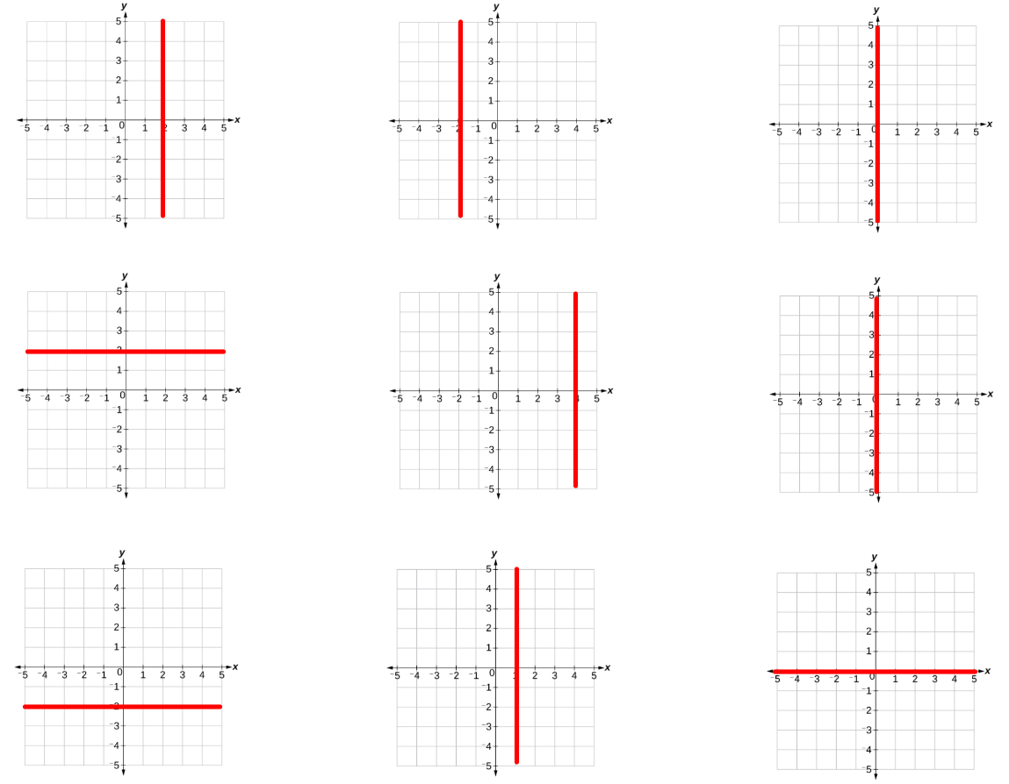  Equation: …………………  Gradient: ………………… | Equation: …………………  Gradient: ………………… | Equation: …………………  Gradient: …………………
Equation: …………………  Gradient: ………………… | Equation: …………………  Gradient: ………………… | Equation: …………………  Gradient: …………………
Equation: …………………  Gradient: ………………… | Equation: …………………  Gradient: …………………

- Sketch horizontal and vertical lines
- Sketch $y=3$ | 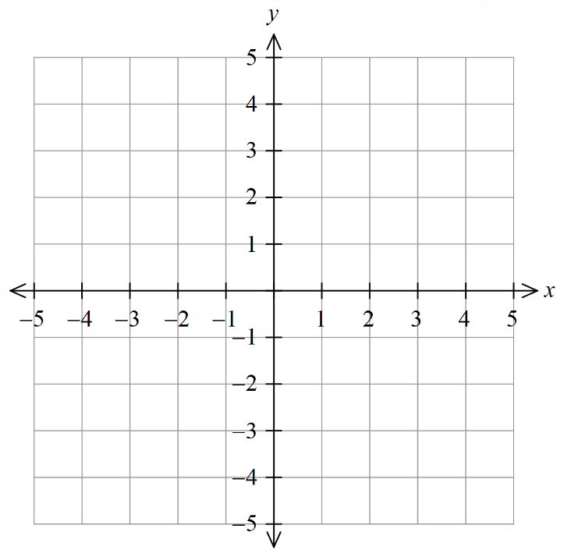  - Sketch $x=-4$
- Sketch $y=5$ | - Sketch $x=-3$
- Sketch $x=3.5$ | - Sketch $y=-2.25$

- Key Ideas
- A ………………… line has an equation of the form $y=c$
- A ………………… line has an equation of the form $x=k$
- The gradient of a horizontal line is …………………
- The gradient of a vertical line is …………………

Foundation
- Sketch the following lines.
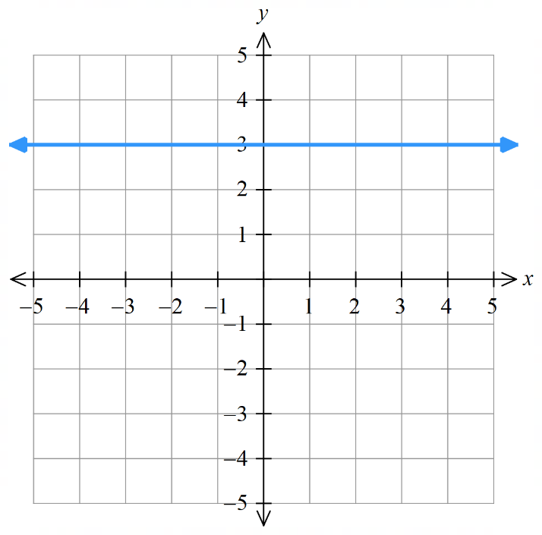  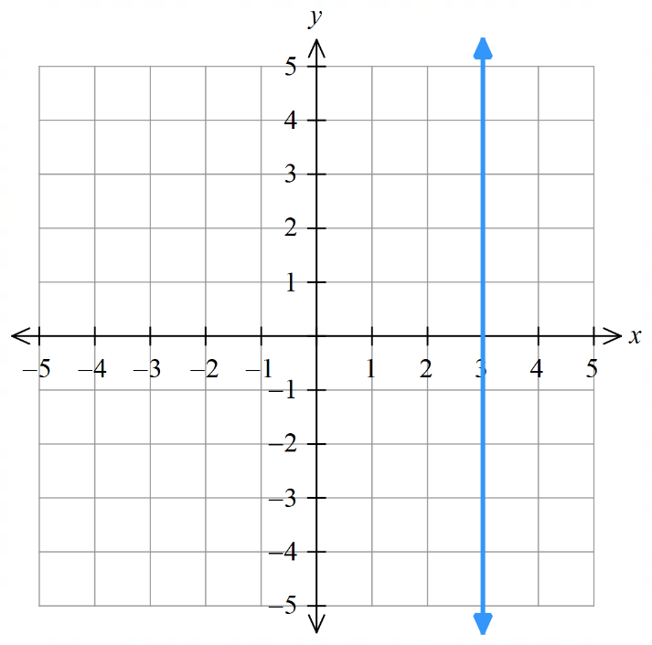  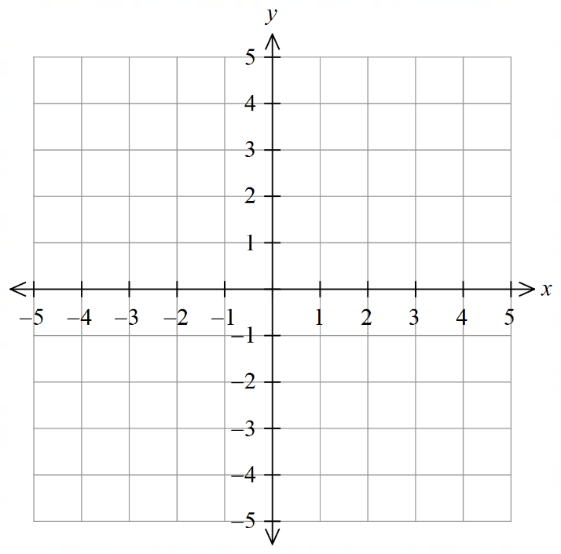  - $x=3$ | - $y=3$ | - $x=-3$  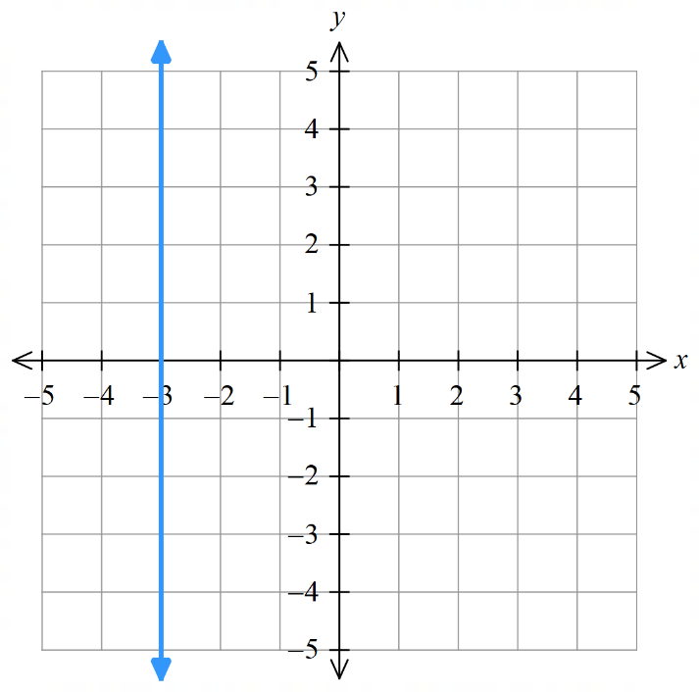
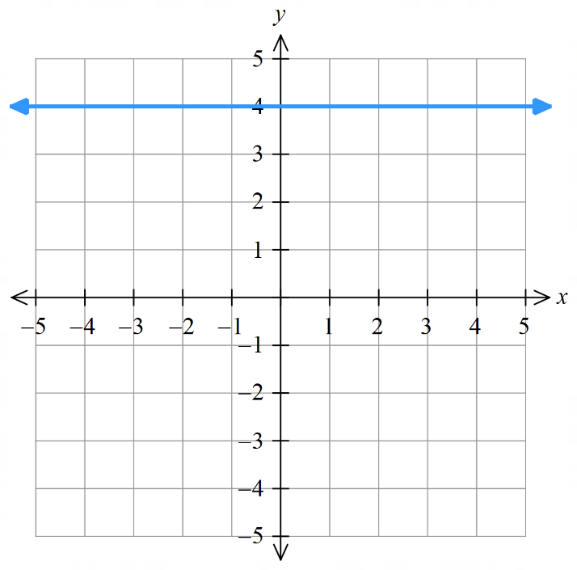  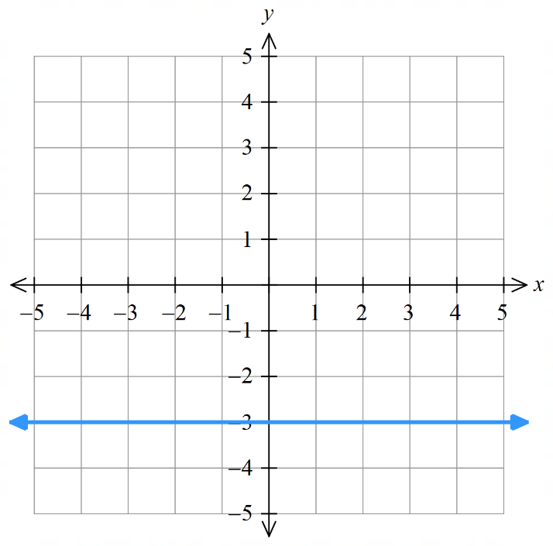  - $y=-3$ | - $y=4$ | - $x=-2.5$  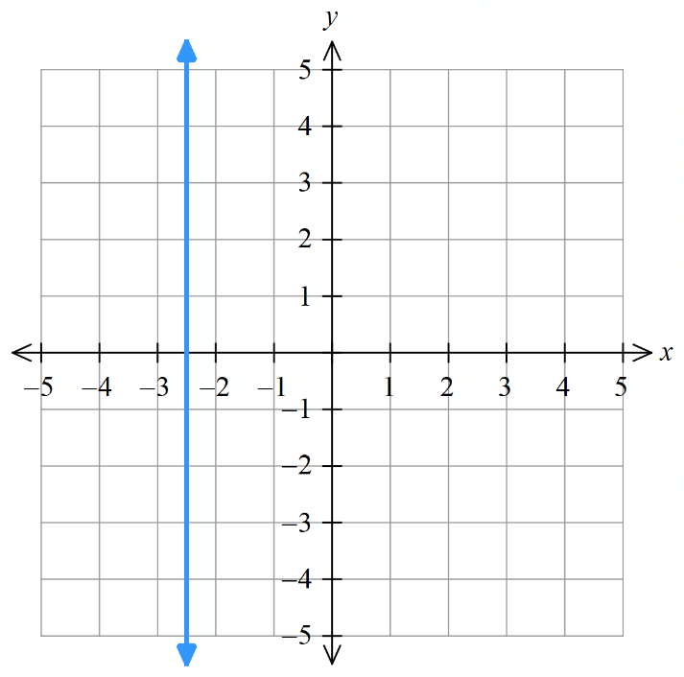

- Plot the points and draw a straight line through the points.
- (-6, 2), (-6, 3), (-6, 0) and (-6,-5).  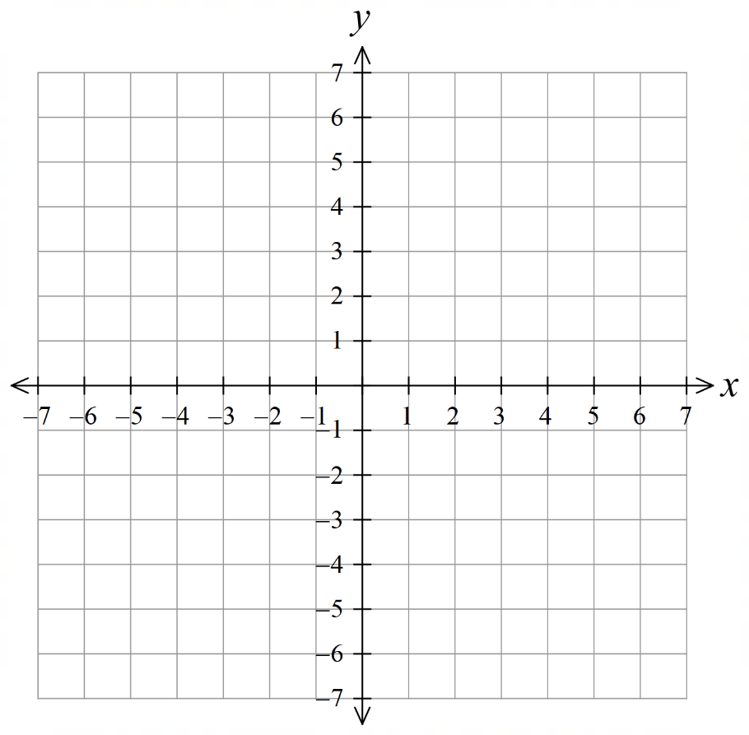  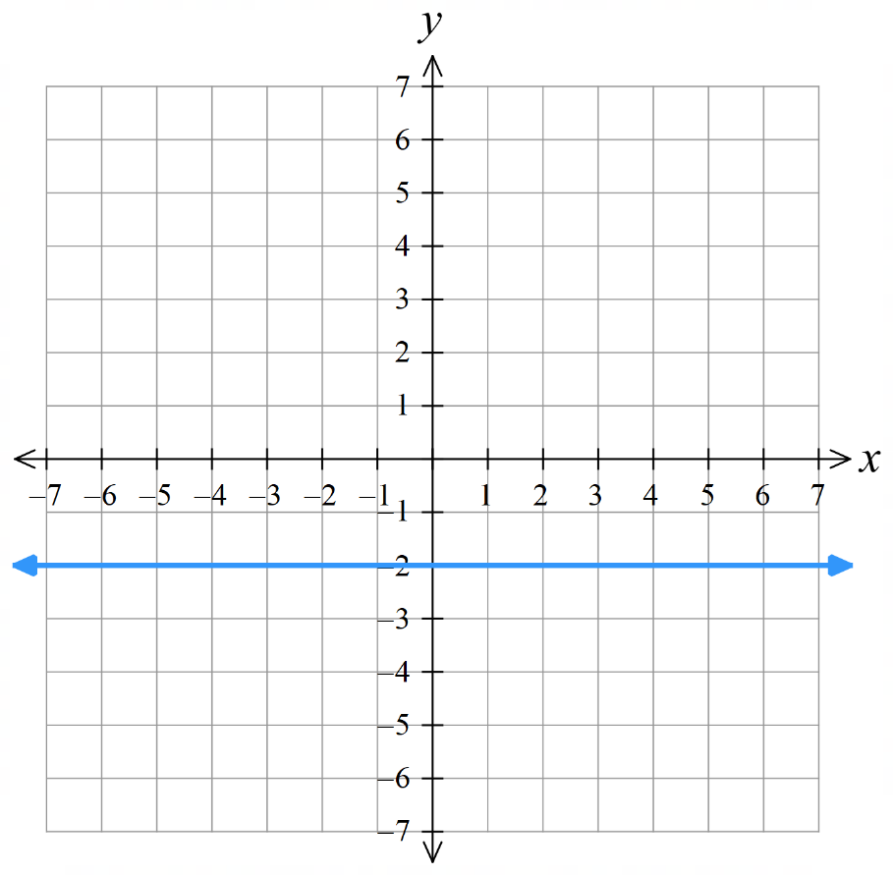  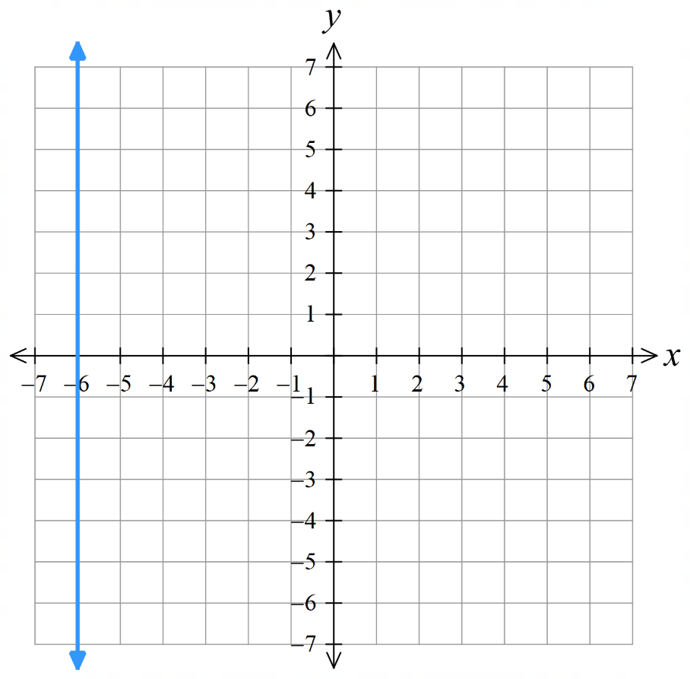  This is the line $x=$ ……  At every point on the line,  the ……-coordinate is equal to ………  –6, $x$, –6 | - (-7,-2), (-5,-2) (0,-2) and (6,-2)  This is the line $y=$ ……  At every point on the line  the ……-coordinate is equal to ………  –2, $y$, –2

Development
- Write the equation of these horizontal and vertical lines.
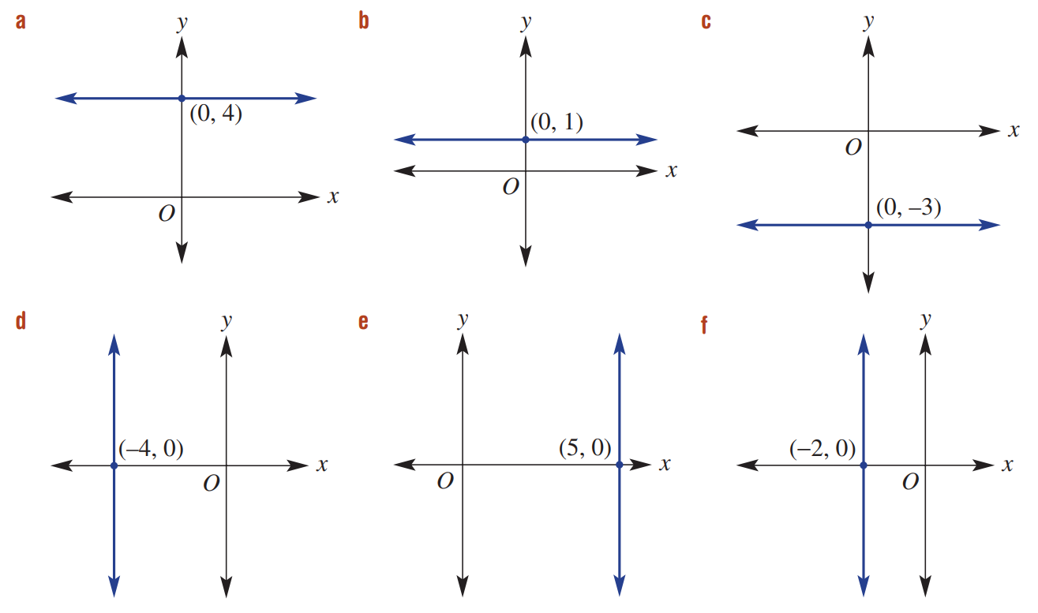  $$y=4$$ | $$y=1$$ | $$y=-3$$
$$x=-4$$ | $$x=5$$ | $$x=-2$$

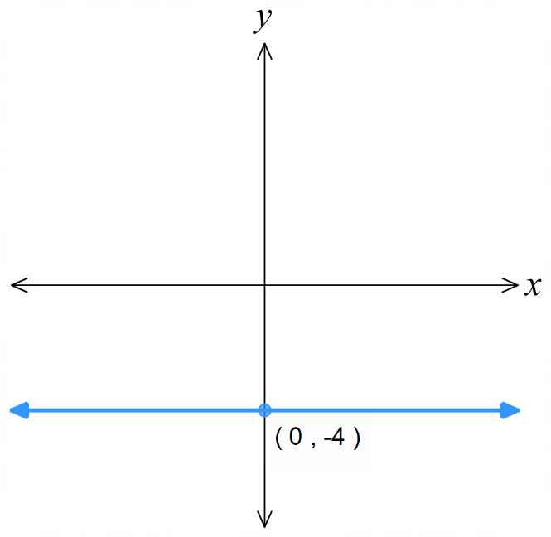
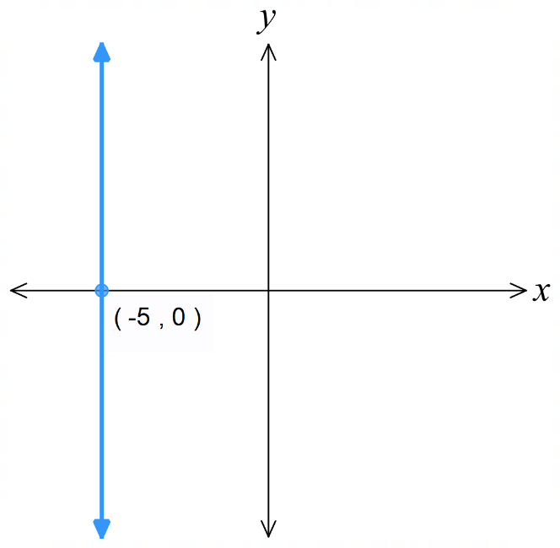
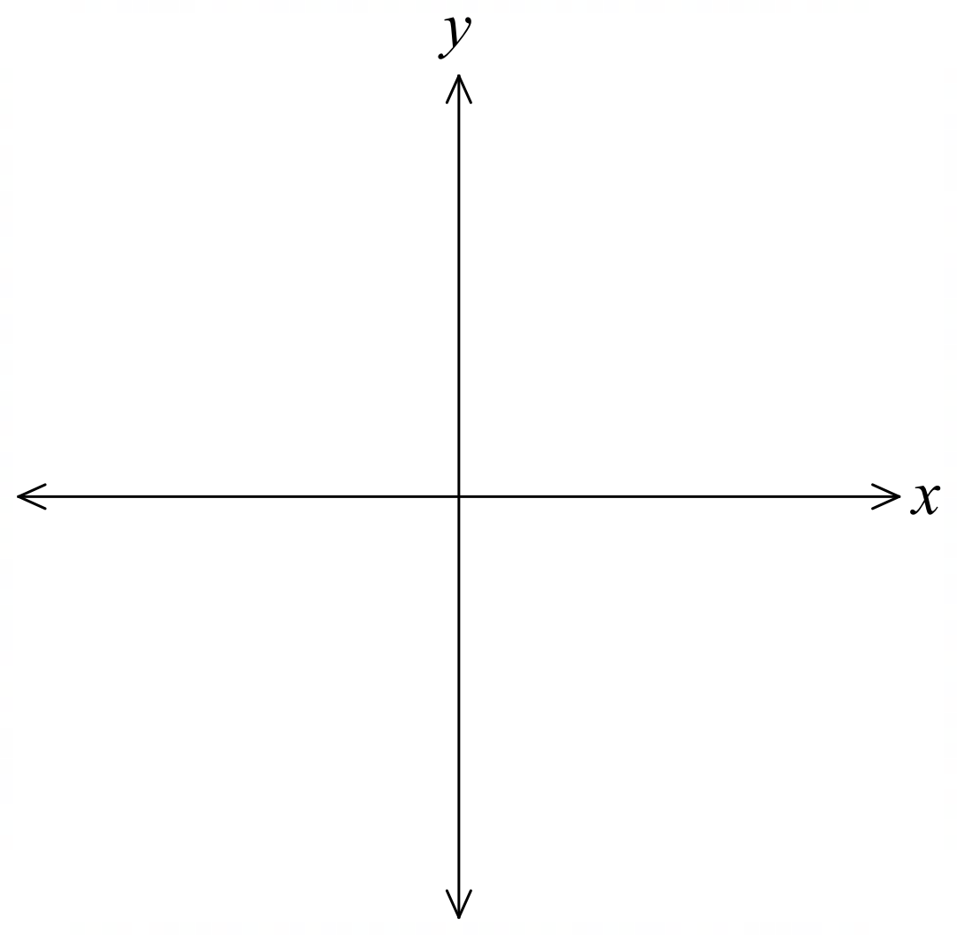
- Sketch the following lines, showing clearly the intercept.
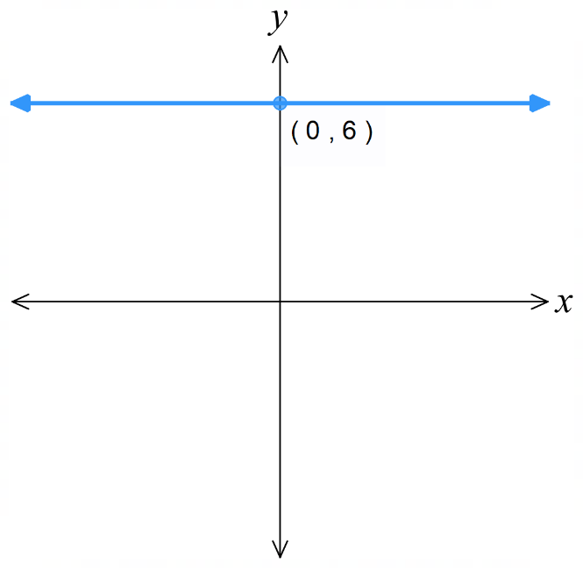  - $y=6$  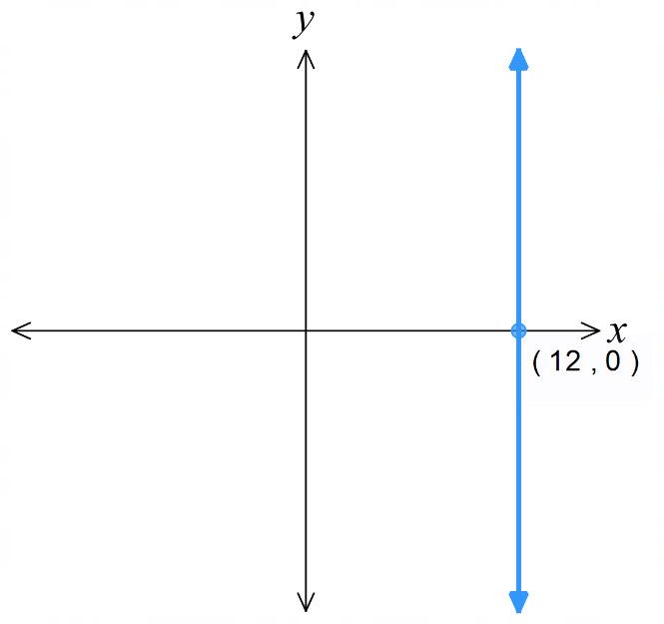 | - $x=-5$ | - $y=-4$
- $x=1.5$  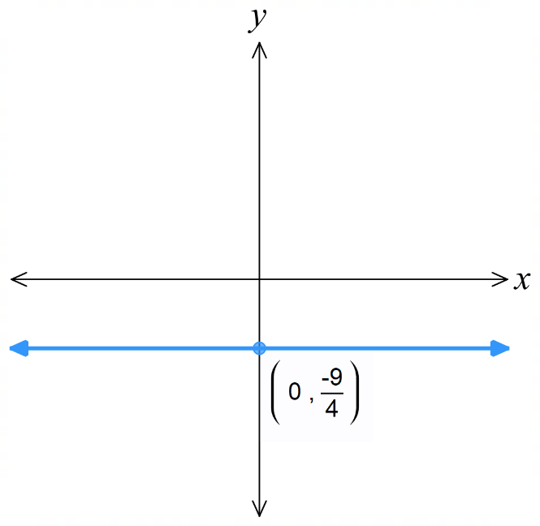  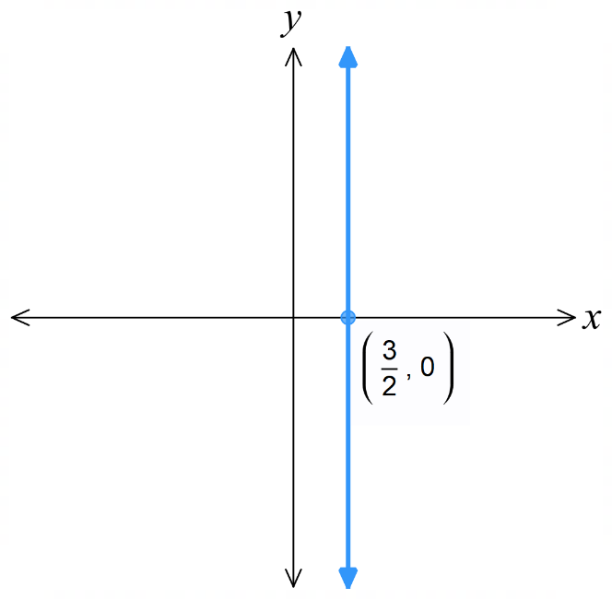 | - $y=-\frac{9}{4}$ | - $x=12$

- Write the equation of the line that is:
  - parallel to the $x$-axis and passes through the point (1, 3)
$$y=3$$
  - parallel to the $y$-axis and passes through the point (5, 4)
$$x=5$$
  - parallel to the $y$-axis and passes through the point (−2, 4)
$$x=-2$$
  - parallel to the $x$-axis and passes through the point (0, 0)
$$y=0$$

  - What is another name for the line $y=0$?
$x$ axis
  - What is another name for the line $x=0$?
$y$ axis
- Find the area of the rectangle contained within the following four lines.
(Hint: sketch the 4 lines on the same axis first).
- $x=1, x=-2, y=-3, y=2$  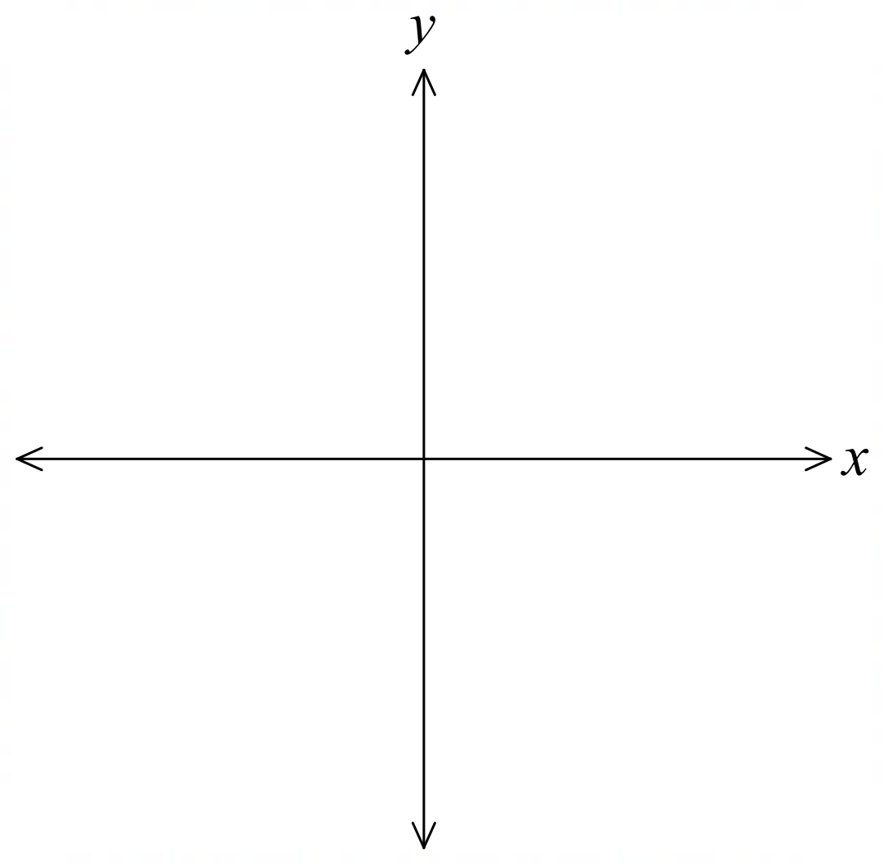  15 u² | - $x=0, x=17, y=-5, y=-1$  68 u²

- The lines $x=-1, x=3$ and $y=-2$ form three sides of a rectangle.
Find the possible equation of the fourth line if:
- The area is 12 square units.  $$y=1$$ | - The area is 8 square units.  $$y=0$$
- The perimeter is 14 units.  $$y=1$$ | - The perimeter is 31 units.  $$y=\frac{19}{2}$$

Intercepts of a Line

- $x$ and $y$ intercepts
$x$-intercept: where the line meets the $x$ axis $\left(y=0\right)$
$y$-intercept: where the line meets the $y$ axis $(x=0)$
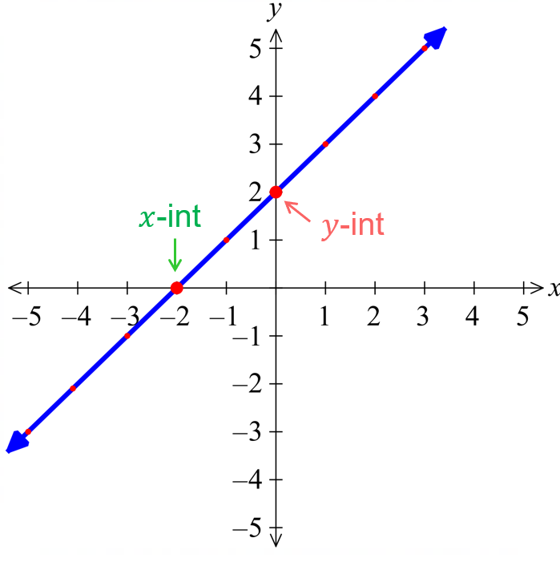
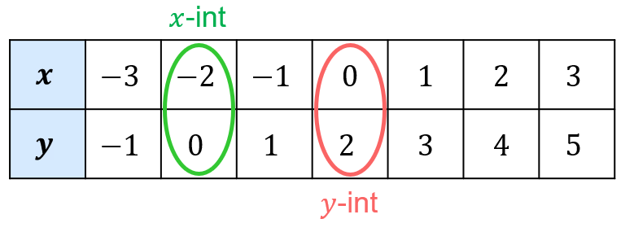

- Identify $x$ and $y$ intercepts of a line
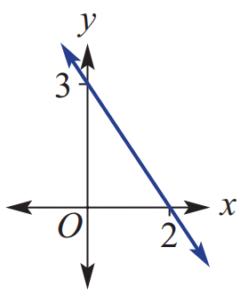  $x$-intercept: ……… $y$-intercept: ……… | $x$-intercept: ……… $y$-intercept: ………
  $$x$$ | $$-2$$ | $$-1$$ | 0 | 1 | 2
  $$y$$ | $$-6$$ | $$-4$$ | $$-2$$ | 0 | 2
$x$-intercept: ……… $y$-intercept: ……… | 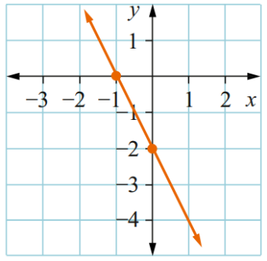  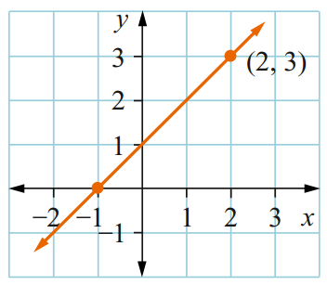  $x$-intercept: ……… $y$-intercept: ………
$x$-intercept: ……… $y$-intercept: ……… | $x$-intercept: ……… $y$-intercept: ………
  $$x$$ | $$-2$$ | $$-1$$ | $$0$$ | $$1$$ | $$2$$
  $$y$$ | $$2$$ | $$0$$ | $$-2$$ | $$-4$$ | $$-6$$
  $$x$$ | $$-2$$ | $$-1$$ | $$0$$ | $$1$$ | $$2$$
  $$y$$ | $$-9$$ | $$-6$$ | $$-3$$ | $$0$$ | $$3$$

Foundation
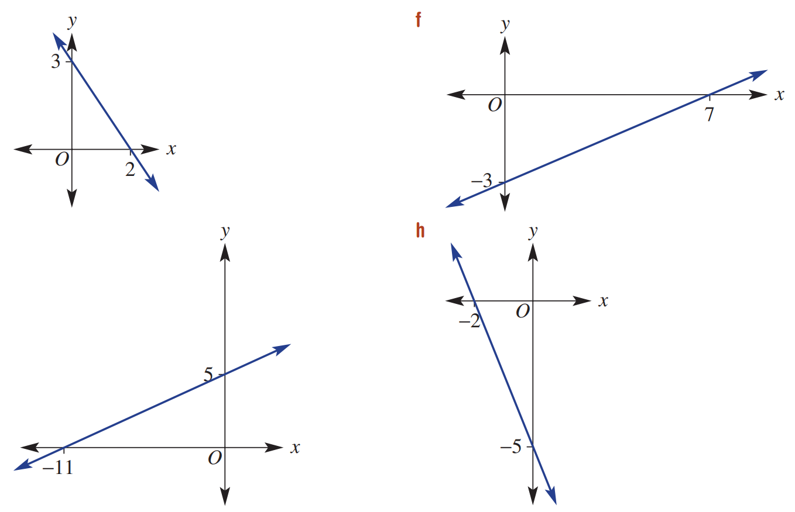
- Identify the intercepts from these graphs.
$x$-intercept:  (2,0)  $y$-intercept:  (0,3) | $x$-int: (7,0) y-int: (0,–3)
$x$-int: (–11,0) y-int: (0,5) | $x$-int: (–2,0) y-int: (0,–5)

- Identify the $x$ and $y$ intercepts from these tables.
$x-$int: ………… $y-$int: …………  $x$-int: (1,0) y-int: (0,1) | 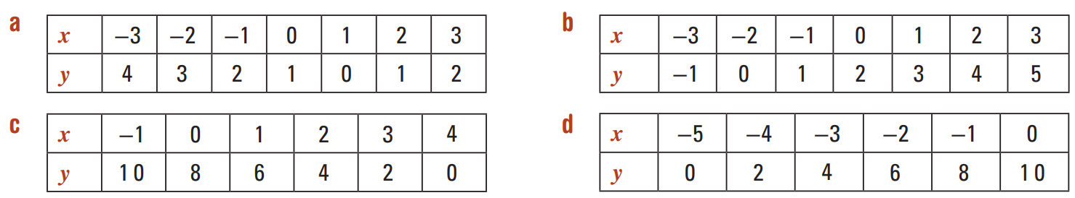  $x$-int: (–2,0) y-int: (0,2)
$x$-int: (4,0) y-int: (0,8) | $x$-int: (–5,0) y-int: (0,10)

- Identify the $x$ and $y$-intercepts from these graphs.
$x$-int: (1.5,0) y-int: (0,3) | 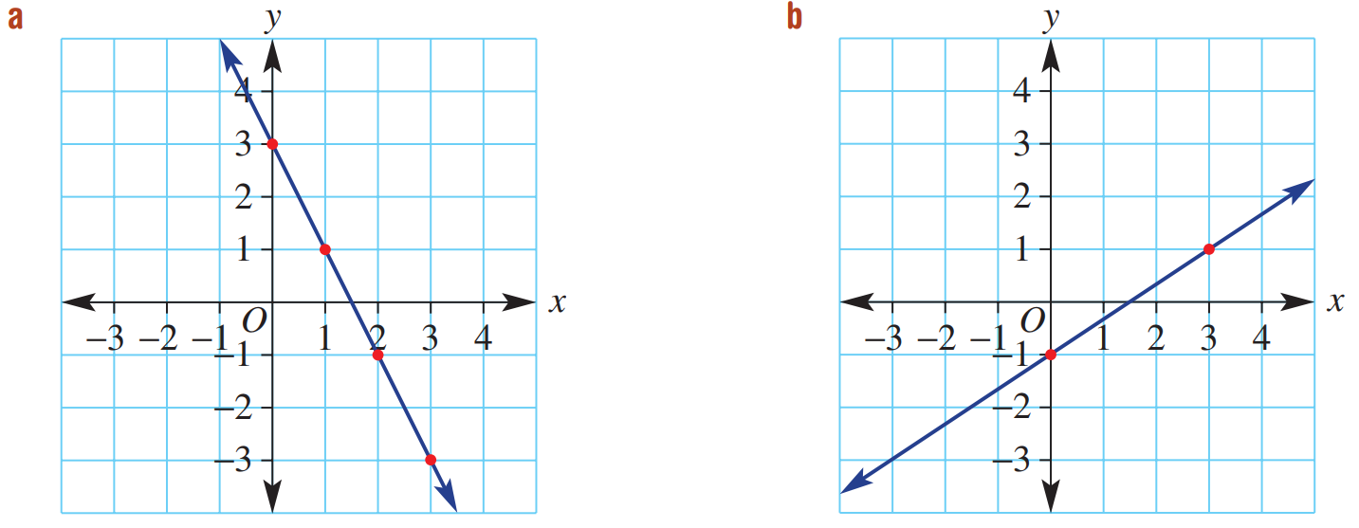  $x$-int: (1.5,0) y-int: (0,–1)

Checking if a Point Lies on a Line

- Review
- Identify that every point on a line is a solution to the equation
- For the point $(3, 7)$ and the line  $$y=2x+1:$$  What is the value of $2x+1$ when $x=3$?  What is the $y$-value of the point? | - For the point $(-1, 4)$ and the line  $$y=5x-1:$$  What is the $y$-value of the point?  What is the value of $5x-1$ when $x=-1$?

- Verify solutions to algebraic equations
- Is $x=4$ a solution to $3x-2=10?$  $LHS=$ $RHS=$ | - Is $x=-3$ a solution to $2x+5=1$?  $LHS=$ $RHS=$

- Checking if a Point Lies on a Line
A point lies on a line when its coordinates make the line's equation true.
- Separate the left-hand side LHS and right-hand side RHS of the equation.
- Substitute $x$ and $y$ values of the point into both sides.
- Compare: If LHS = RHS, it lies on the line. If LHS ≠ RHS, it does not lie on the line.

- Example Check whether a point lies on a line by substitution
Decide whether $(2,5)$ lies on the line  $$y=2x+1$$ | Decide whether $(-2,-5)$ lies on the line  $$y=2x+1$$
  $LHS=y$  $=5$ | $RHS=2x+1$  $=2\left(2\right)+1$  $=5$
  $$LHS=RHS$$
  $(2,5)$ lies on the line $y=2x+1$
  $LHS=y$  $=-5$ | $RHS=2x+1$  $=2\left(-2\right)+1$  $=-3$
  $$LHS≠RHS$$
  $(-2,-5)$ does not lie on line $y=2x+1$

- Guided Practice
- Decide whether $(-2,4)$ lies on the line  $$y=-x+2$$  yes | - Decide whether $(11,23)$ lies on the line  $$y=35-x$$  no
  $LHS=$ | $RHS=$
  $LHS=$ | $RHS=$

- Key Ideas
- A point lies on a line if its coordinates make the equation ………………
- If the coordinates of a point do not satisfy the ………………… of the line, then it does not lie on the line.

Foundation
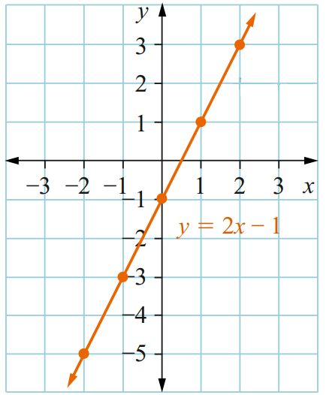
- Does the point $(2,2)$ lie on the line $y=2x-1$?
$LHS=y$  $=$ | $RHS=2x-1$  $=$  $=$
$LHS$ …… $RHS$
The point $(2,2)$ does | doesn’t lie on the line $y=2x-1$
no
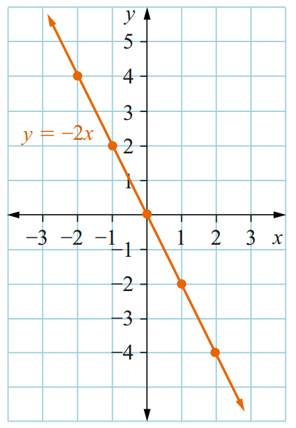
- Does the point $(-1, 2)$ lie on the line $y=-2x$?

$LHS=$  $=$ | $RHS=$  $=$  $=$
$LHS$ …… $RHS$

yes
- Does the point $(-3, -2)$ lie on the line $y=\frac{1}{2}x-1$?
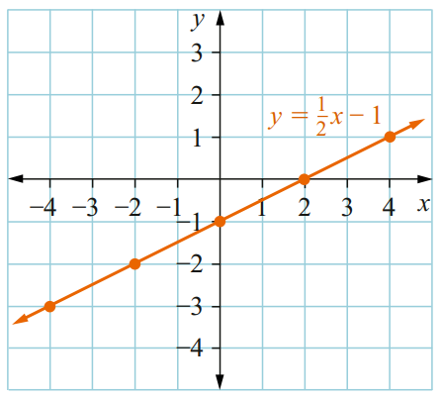
$LHS=$  $=$ | $RHS=$  $=$  $=$
$LHS$ …… $RHS$

no

Development

- Does $(1,-3)$ lie on the line $y=x-4$?  yes | - Does $(0,2)$ lie on the line $y=2x$?  no
  $LHS=$  $=$ | $RHS=$  $=$
  $LHS$ …… $RHS$
  $LHS=$  $=$ | $RHS=$  $=$
  $LHS$ …… $RHS$
- Does $(4,1)$ lie on the line $y=\frac{x}{2}$?  no | - Does $(1,-2)$ lie on the line  $y=-x-3$?  no
- Does $(5,4)$ lie on the line  $y=1-x$?  no | - Does $(-2,-1)$ lie on the line  $y=2x+3$?  yes
- Does $(-4,-11)$ lie on the line  $y=2x-3$?  yes | - Does $(-5,4)$ lie on the line  $y=3-2x$?  no


- Mila says:
any line of the form $y=kx$ will go through the origin.

Explain why she is correct.
$x=0, y=0$ will always be a solution to $y=kx$

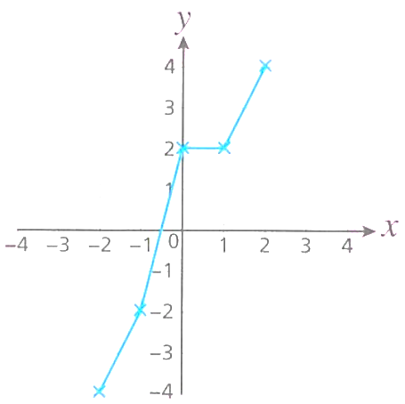
- Rob has drawn the graph of $y=2x$.
  - Explain how you know he must have made a mistake.

This is not a straight line.
  - Which point is incorrect? Justify your answer.

(0,2), as when $x=0, y=0$

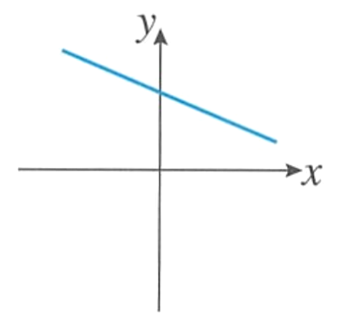
- Ed has drawn the line with equation $y=-x$.
Explain how you know that Ed must have made a mistake.

This line must go through the origin as (0,0) is a solution.

- A straight line has equation $y=5x+2a+3$ . The line passes through the point $(0,19).$
Work out the value of $a$.

Substitute into equation
$$19=5\left(0\right)+2a+3$$
$$2a=16$$
$$a=8$$

- A line has gradient 3 and passes through the point $\left(1,7\right)$. Find its equation $y=mx+c$.

$$y=3x+c$$
$$7=3\left(1\right)+c$$
$$c=4$$
$$∴y=3x+4$$

